**FACULTY OF SCIENCE, ENGINEERING AND COMPUTING**

**School of *Computer Science & Mathematics***

**FACULTY OF SCIENCE, ENGINEERING AND COMPUTING**

**School of *Computer Science & Mathematics***

**BSc DEGREE**

**IN**

***Computer Science (Software Engineering) Top Up***

**FINAL REPORT**

Name: **Mohamed Fariq Abdulla Sabith**

ID Number: **E026503**

Project Title: **Leisure Diary**

Project Type: **Build**

Date: **17.03.2023**

Supervisor: Ms. Sampa Rasanie



Did you discuss and agree the viability of your project idea with your supervisor? Yes

Did you submit a draft of your proposal to your supervisor? Yes

Did you receive feedback from your supervisor on any submitted draft? Yes or No

**Abstract**

Leisure Diary is a solution proposed by AFADAMAD (Pvt) Ltd, a travel agent that aims to assist travelers with their inbound and outbound travel needs to ensure their satisfaction by providing a hassle-free, all-in-one trip organizer. The solution offers a wide range of features that reduce the workload of the organizer and provide the required resources at their fingertips. It provides a convenient platform for all the requirements of a traveler and offers an opportunity for related stakeholders to grow their businesses. This report contains all the details about the technologies, methodologies, work plan, constraints, and ways to overcome them.

**Contents**

Introduction & Literature Review 1

1.1 Introduction 1

1.2 Background and Motivation 1

1.3 Problem in brief 2

1.4 Aim & Objectives 3

1.4.1 Aim 3

1.4.2 Objectives 3

1.5. Scope 3

1.1. Project Scope Statement 3

1.6 Deliverables 5

1.5.1. Milestone Schedule 5

1.5.2 Gantt Chart 6

1.7 Literature Review 6

2. Analysis 8

2.1 Use case diagram 9

2.2 Clear problem definition 10

2.3 User stories 11

2.4 SWOT Analysis 11

2.5 Requirement Engineering 12

2.6 Resource requirements 16

2.7 Outcome of the analysis 17

3. Design 18

3.1 Design Techniques 18

3.1.1 Flow Chart 18

3.1.2 Use Case Diagram 20

3.1.3 ER Diagram 20

3.1.4 High Level System Component Diagram 21

3.2 System Overview 22

3.2.1 Wireframes 23

3.2.2 System Architecture 27

4. Product Implementation 28

5. Validation 37

6. Critical Review & Conclusion 42

6.1 Closing executive summary 42

6.2 Conclusion 42

References 44

**List of Figures**

Figure 1 Gantt Chart 6

Figure 2Use case diagram 10

Figure 3 Service provider Flow chart 19

Figure 4 Travelers flow chart 19

Figure 5- User case diagram 20

Figure 6 ER Diagram 21

Figure 7 System component diagram 22

Figure 8 Wireframe Sketch 23

Figure 9 Wireframe 24

Figure 10 Wireframe 24

Figure 11 Wireframe 25

Figure 12 Wireframe 26

Figure 13 System Architecture 28

Figure 14- Folder Structure 29

Figure 15- DB connection 29

Figure 16 Routing codes 30

Figure 17 Routing Codes 31

Figure 18 Libraries 31

Figure 19 Server implementations 32

Figure 20 API Endpoints 32

Figure 21 API Endpoints 33

Figure 22 HTML Views 34

Figure 23 EJS Templating 35

Figure 24 EJS Templating 35

Figure 25 Libraries 36

Figure 26 API Integration 37

Figure 27 Validations 38

Figure 28 Testing 39

Figure 29 DB connection code 39

Figure 30 Test case 40

Figure 31MongoDB connection 40

Figure 32 DB connection 2 41

Figure 33- API testing 41

**List of Tables**

Table 1- Project scope statement 4

Table 2 Milestone Schedule 6

Table 3-SWOT Analysis 12

Table 4 Functional Requirements 15

Table 5 Performance requirements 16

Table 6 Privacy and security requirements 16

Table 7 Software Quality Requirements 16

Table 8 Resource requirements 17

**Glossary of Terms**

HTML: Hyper Text Markup Language  
IDE: Integrated Development Environment  
CSS: Cascading Style Sheet

RAM: Random Access Memory

JS: JavaScript

API: Application Programming Interface

# Introduction & Literature Review

## 1.1 Introduction

AFADAMD (Pvt) Ltd is a travel agent that assists travelers with their inbound and outbound travel needs. They also act as trip advisors to ensure that travelers are always satisfied. The company's aim is to provide a hassle-free travel experience to all travelers who engage with them. They have a vast network of hotels, resorts, other leisure activities, and related services within their chain.

Tourism has experienced significant growth over the years, with its impact involving all economic aspects of countries, businesses, and individuals. However, countries and related businesses must be involved in improving the tourism industry. The purpose of this project is to achieve the above and mitigate problems faced by travelers and other related business entities through effective communication.

The primary scope of the project is to provide an all-in-one solution for planning and organizing trip-related aspects without any hassle. It will also act as a pillar for effective communication between stakeholders

## 1.2 Background and Motivation

In today's fast-paced world, people often find themselves struggling with the stresses of daily life. Traveling has become one of the most popular methods for individuals and families to unwind and spend quality time together. However, planning a trip can often be a daunting task due to the multitude of associated entities. Additionally, businesses play a significant role in the tourism industry and are considered stakeholders in trips.

With the majority of internet users accessing the web through mobile devices, reaching travelers through mobile applications has become the most effective method. Proper communication is essential to resolve any potential issues faced by foreign travelers [1]. While there are numerous travel applications available in the market, there is currently no all-in-one solution.

Separate applications for each entity do not effectively connect them together, and travelers and organizers seek convenience in a single application. A successful application ultimately leads to customer satisfaction, which is the ultimate goal. Trip organizations involve multiple tasks that can make it difficult for organizers to engage in the arrangement of the trip while others are enjoying it. The tourism service chain is continually improving, and the involvement of each sector is essential in its overall success.

The primary focus of mobile or any other type of application development is to improve the user experience (UX), as it is crucial to the value of the application. Users always expect a more convenient solution, and thus, solution providers must evaluate user requirements as a critical initial task. A user-friendly solution will attract new users to the application.

## 1.3 Problem in brief

Planning a trip can be a daunting process, particularly when it comes to accommodating the interests and preferences of multiple individuals. The process typically involves a myriad of tasks, including choosing a destination, arranging transportation, finding suitable accommodation, planning meals, and organizing daily activities throughout the trip. For many people, the purpose of a trip is to unwind and relax from the daily grind, making the planning process an unwelcome chore.

One major challenge that arises during trip planning is the burden that falls on those responsible for organizing the trip. While others get to enjoy the trip, the planners often remain preoccupied with making arrangements and ensuring that everyone's expectations are met. This problem is particularly acute when planning trips involving large groups, such as corporate or school trips, where coordinating transportation, accommodation, and other logistics can be a formidable task.

Currently, there are numerous applications on the market that provide booking services for hotels, transport, and food. However, there is no all-in-one solution that enables users to plan their entire trip and share the plan with service providers without encountering any additional hassles during the trip.

## 1.4 Aim & Objectives

### 1.4.1 Aim

The aim of this project is to develop an all-in-one mobile application to plan, organize and review a hassle-free trip to travelers’ solution with all the related stakeholder involvement.

### 1.4.2 Objectives

* To identify and provide all in one solution to the travelers to address all their needs through one application.
* To suggest recommendations for the travelers to get decisions on planning a trip.
* To design an application which can find fulfill all the aspects of needs of all the stakeholders.
* To build a communication and interaction method between travelers, service providers and the organizers.

## Scope

The scope of the project that refers to the specific set of outcomes or results that need to be delivered based on the project requirements. It outlines what is included and excluded from the project and governs what can be added or removed during the implementation phase. In this project the scope implements a mobile application along with a web application to serve the travelers a hassle-free travel experience where all their needs to be found in one place. This it to make the travelling experience more efficient and time saving. Also, which will help the businesses to reach their clients easily. Throughout a SWOT analysis we have identified the identify the project's strengths, weaknesses, opportunities, and threats.

### Project Scope Statement

A project scope statement is a document that defines the objectives, goals, deliverables, and boundaries of a project. It outlines what the project will accomplish, what is included, and what is not included. The scope statement also includes a description of the project's stakeholders, assumptions, constraints, and risks. It serves as a reference for the project team and stakeholders to ensure that the project stays on track and meets its objectives [2].

|  |  |
| --- | --- |
| Project Scope Statement | |
| Project Name | Leisure Diary |
| Project owner | Sabith Fariq |
| Date |  |
| Product Scope Description | Scope:   * Requirement analyzing and engineering. * Identifying the flow and mapping the Flow charts, Data Flow Diagrams, ER Diagrams and Prototyping * Designing and developing the Leisure Diary Mobile app and Web Application. * Testing the implementation * User Manual * Documenting |
| Project Deliverables | * Project proposal * Project Gantt Chart and Milestone Schedule * Design document * Develop Mobile app * Develop Web App * Test Document * User manual * Final Report |
| Constrains | * Time * Resource |
| Acceptance Criteria | The project scope is agreed and accepted by the management. |

Table - Project scope statement

## 1.6 Deliverables

The deliverables describe the primary outcome of the project as the result of the scope. Hence, we have different roadmaps and tracking tools to reach the success without any constrains. In the form of charts, the tools will be laid as the path to reach project objectives as mentioned above.

The project delivers followings,

* Project Gantt Chart and Milestone Schedule
* Design document
* A Mobile app for the travelers
* A Web App for the service providers
* Test Document
* User manual
* Final Report

### Milestone Schedule

|  |  |  |  |
| --- | --- | --- | --- |
| **Number** | **Task** | **Deliverables** | **Time period** |
| 1 | Requirement gathering and analysis | * Functional and non-Functional requirements * Gantt chart * Milestone Schedule * Project proposal | December- January 2023 |
| 2 | System Design | * Prototyping * UI/UX Designing * Requirement Engineering * Design Diagrams | January – March 2023 |
| 3 | System Implementation | * Mobile Application * Web Application | March – April 2023 |
| 4 | Testing | * Testing reports | March – April 2023 |
| 5 | System deployment and submission | * Final report * Developed product | March – April 2023 |

Table Milestone Schedule

### 1.5.2 Gantt Chart

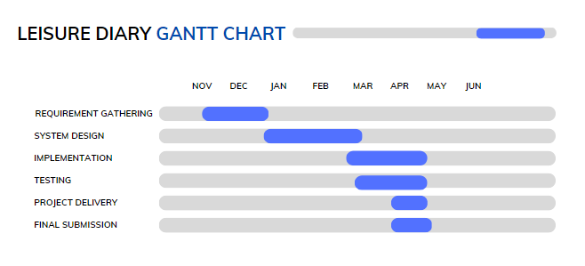

Figure Gantt Chart

## 1.7 Technologies & Resources

### 1.7.1 Technologies

### 1.7.2 Resource requirements

Describe it

|  |  |
| --- | --- |
| Software requirement | * Visual Studio code editor * Windows 7 or above * MongoDB/Firebase * Android studio |
| Hardware Requirements | * Personal Computer * 8GB RAM or higher * 500GB HDD * 1GB Video Graphics card or Higher |
| Client requirement | * Mobile phone with internet connection * A PC with internet connection |
| Technological requirements | * HTML * CSS * JavaScript * Flutter * MongoDB / Firebase * EJS |

### 1.7.3 Libraries and APIs used

The Leisure Diary application has been made using many APIs and libraries to make the development process faster and smoother. Following are the APIs and Libraries used to build the Leisure Diary web application and Mobile application.

**Google Map API.**

Google Cloud Console is a web-based tool that lets the developer to manage the resources and services on the Google Cloud Platform. It is a central location where you can access and control your resources, such as virtual machines, databases, and storage buckets.

The Google Maps API is used to access Google Maps in the applications. This means it provides the ability to create and customized maps, add markers, and display directions. It's a very powerful tool and widely used in many different industries.

A separate project has been created in Google Cloud Console for Leisure Diary system implementation.

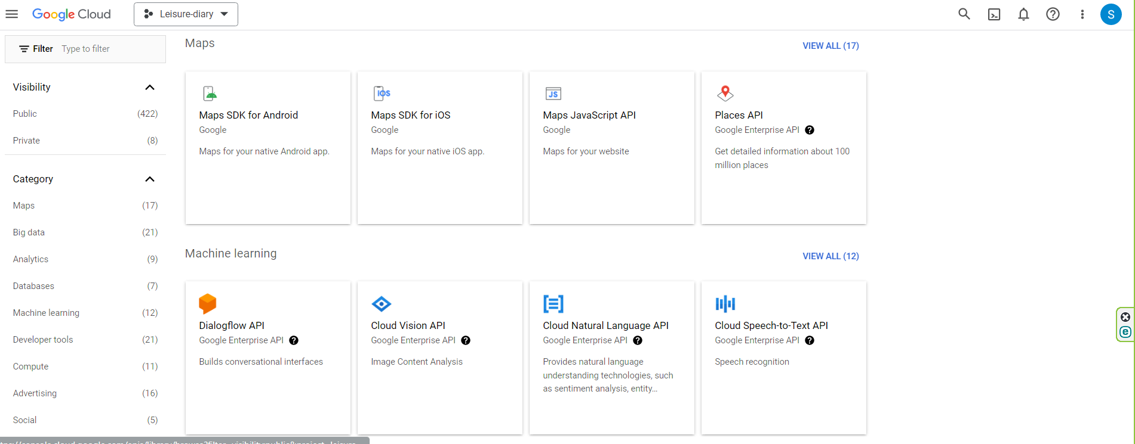

Figure - Google cloud console integration

The one of the library Maps JavaScript API helps the user to search and find the exact location when creating new services. Also, it will assist other component to render the linked location API whenever its required.

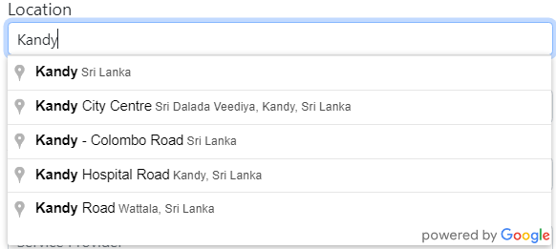

Figure - Location API

**Express.js**Express.js is a JavaScript popular framework which is used to build web applications and related APIs. Express.js can be used to develop route to the pages and endpoints. The framework also helps to handle and interact HTTP requests.



**mongooseValidationErrorHandler**

mongooseValidationErrorHandler is a popular library which helps as a middleware in handling validation errors when interacting with mongoDB. mongooseValidationErrorHandler also helps to understand the error easily.

**Multer**

Multer is also a middleware which helps to handle file uploading. Node.js uses the Multer library to simplify the file handling and limiting the file sizes.

**Fs**The Leisure Diary system has a component to read, write and modify the files. To achieve the task node.js uses its inbuilt library “Fs”

**Dotenv**

Dotenv files are used to store sensitive and confidential data such as Database connections, API Keys and Port details. Main concept of the Dotenv files is, If the developer builds an application and had to share it with other stakeholders or third-party people. Dotenv file which has the confidential data can be removed. The recipient will have to create their own credential and access the application.

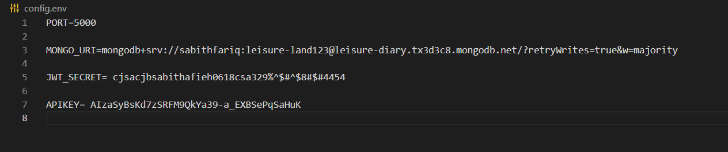

Figure - Dotevn configuration

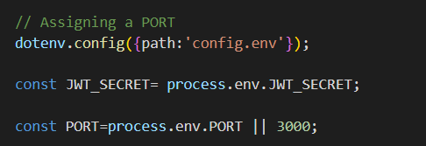

Figure Dotenv Usage in the file

**bcrypt**

The Node.js library bcrypt serves to hash passwords. By using a salt and a one-way hash function to hash the passwords, it offers a secure means to store them, making it impossible for hackers to decipher the original password. In the Leisure Diary application, there are two types of users, can register them self in the system. When they enter the password, it will **bcrypt** and saved in the database. Whereas no one can access or read the password.

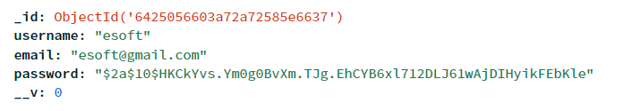

Figure - Service provider registration

**Travelers Signing up through the mobile app**

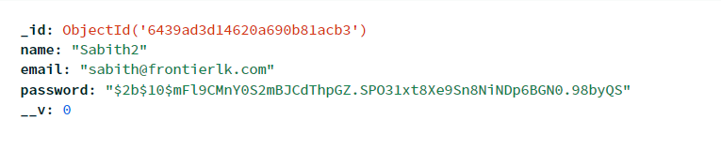

Figure - Traveler registration

**JWT**

JWT is used to generating and validating secure tokens in web applications, or JSON Web Tokens. Users are authenticated using JWTs to grant access to restricted resources.

**Morgan**

Morgan is a middleware for that handles and logs HTTP requests and responses. It quickly records the details about each request, such as the method used, the URL, the response status code, and more.

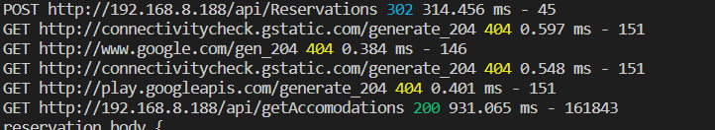

Figure - Morgan Model

**Session**

Node.js's Session middleware helps manage user sessions. Users can maintain their authentication over numerous requests due to a method for storing and retrieving session data across requests.

**BodyParser**

BodyParser is a middleware which is used to parse HTTP request bodies. It offers a mechanism to extract JSON, form data, and other forms of data from HTTP request bodies. [3]

## 1.8 Literature Review

Trip planning is an essential part of tourism and travel. It entails planning, selecting, and analyzing key modules of a journey, including lodging, activities, transportation, and finances. Travelers now have access to a variety of tools that can help them plan their vacations thanks to the development of technology and the ease with which information is available online.

Wang and Chen stated [4] in their study that majority of tourists prefer to use online platforms for travel planning and organizing via websites, social media contents and travel agencies. Also, their study indicates that travelers who have used online platforms to plan and organize their trips are more satisfied. People engage in a variety of activities to have fun and refresh their minds from monotonous tasks at work or in daily life, including fishing, watching TV or movies, hanging out with friends, and many others. Touring is one of those activities. according to the Indonesian lexicon. Tourism is a leisure travel-related activity.

According to Soekadijo [5] Tourism refers to both the temporary movement of individuals to locations other than their usual areas of residence and employment, as well as the activities they engage in while there. There are a few components that tourists can appreciate to make their trip memorable and interesting.

A study conducted by Lee et al. (2008) indicates the factors which effects the decision-making process of travelers through his study. It also shows how attractive is the destination, convenience and cost are the major factors considered by the travelers when making decisions. Further, the study clearly indicates that travelers more often use online reviews and recommendations posted by other travelers as a key assistant to make decisions [6].

The study which was carried by Deegan et al, which evaluated the planning and organizing element on overall travel experience says the quality of travel planning was positively related to travel satisfaction and loyalty. Also, the study indicated that travel agencies and companies should focus more on creating more personalized packages and travel planning services to enhance and satisfy the travelers [7].

As we aware the tourism is a one of the fastest growing industries in the world. The function of travel planning in encouraging sustainable travel behavior has drawn more attention as the importance of sustainable tourism has grown. The desire of tourists to engage in sustainable travel behavior during the trip preparation phase was examined in a study by Vu and Tasci (2018). Tourism attitudes toward sustainable travel, perceptions of the place, and perceived behavioral control were discovered to be important determinants of travelers' intentions to practice sustainable travel [8].

T. D. Hinch and J. E. S. Higham [9] carried in their study and analyzed that the rise in sport tourist activities caused by the availability of different sports. In certain ways, sport tourism contributes to all aspects of life. The subject of research is different sports that are used by tourists.

Leiper [10] has stated there are three main activity occurring elements available,

1. Travelers

Travelers are the main role play of the activities of tourism. In such activities they gain memories and experiences lasts their whole period of life.

1. Geographic components

Above travelers’ movement are takes in to account as Geographical components. Geographic component has three sub components,

* Region of Origin – The place of origin of the travelers. Where they do all their daily lifestyle activities.
* Regional Transit- Not every passenger was required to make a stop there. Yet, all travelers undoubtedly pass through that region, therefore the object destinations will play a crucial part.
* Destination Region-Creates demand for travel to a certain tourist site and acts as a booster for the entire tourism system.

1. The tourism industry

The industry which provides the travel related services and other activities.

The definition of tourism can be drawn from these explanations. It is a happy pastime geared for amusement and leisure pursuits for travelers. Up to the trip's conclusion, there is no melancholy. Being joyful all the time is one of the things tourists do. Because of tourists who appreciate tours, they can choose the type of tourism they prefer in advance. After work or other activities, the majority of people utilize travel as a mood enhancer and media to recharge their brains. Tourists can feel better than previously by participating in the activities they receive as part of their tour.

Tourists have a wide range of tourism options. People can choose and explore before enrolling in tourism-related activities. Also, they can be more particular about the type of tourism they prefer.

According to Spillane [11] the types are determined by the selected destination. Types of the tourism as follows,

* **Enjoyment trip**

Pleasure tourism is the kind of tourism practiced by individuals who travel away from home for a holiday in order to take in some fresh air, quench their curiosity, dry their eyes, see something new, take in the beauty of nature, learn about the locals, or simply to find calm in the village.

* **Recreation**

Tourism recreation refers to travel that is done by individuals who use their vacation time to rest, restore their sense of freshness, or who wish to relieve fatigue.

* **Cultural**

The kind of this tourism is distinguished by a reason, such as the desire to study at research and teaching facilities, to discover the traditions and way of life of people in other nations, or to see historical sites or artifacts from earlier civilizations.

* **Sport**

Sport events are the main emphasis of sport tourism. Sport tours or sport tourism refers to everything that is connected to sports and includes travel. There are two distinct categories for sport tourism:

* + Major sporting events Large-scale sporting events like the Olympics, the ski world championships, the World Cup, and others garner attention from both fans and spectators.
  + The practitioners' use of sporting tourism For those who like to do sports alone, such as mountain climbing, horseback riding, hunting, fishing, and other activities, sport tourism is a good option.
* **Business**

Theorists contend that this was a business trip taken by a travel expert or that it was necessary given the nature of the suspect's position or employment, which limited his or her options for travel dates and locations.

* **Convention**

A tourism convention or meeting is a gathering that draws hundreds or even thousands of attendees, who often spend a few days in the host city or nation. [11]

While Yoeti (1995) [12] defined tourism as a conscious activity that rotates among the people in a country that includes the standing of another region for a while in pursuit of the satisfaction of various and different from what happened in their home country, this is not the case now.

Thus, a journey or activity that is centered on providing pleasure and relaxation is called tourism. If such phrases are put together, the result will be a trip that focuses on horror activities as amusement and leisure pursuits.

According to specialists, there are many different types of tourism, including commercial tourism, sport tourism, and nature tourism. A type of tourism that belongs in pilgrimage or ziarah is the horror tour. Due of horror tourism, visitors are invited to a location that many people regard as sacred. Pendit (1994) [13]defined pilgrimage tourism as a journey to holy locations, the tombs of great or exalted leaders, or to hills or mountains that are thought to be sacred graveyards of human figures or leaders as full-fledged magical legends.

Tour packages are a type of commercially produced media that tour operators offer to travelers. Mansur (2009) [14]states that a tour package is a tourists' itinerary of activities that has been put together and is maintained at a set cost, and that includes travel, lodging, sights and attractions, as well as other ancillary services that are offered under the terms of the tour package. According to Kotler and Armstrong (1989) [15], a tour package is something that is provided to the customer or market share to appease a whim and desire that includes tangible goods, services, human resources used by the firm, and ground-breaking or innovative ideas.

**Mobile Application for travel**

Buhalis (2008) has reviewed in his article that there are variety of mobile applications available for the travelers also the author has mentioned there are plenty of features and functionalities on travel applications which bring the convivence for the travelers [16]. In recent years it has proved that travel apps have become increasingly popular among travelers. Studies and researches have explored the factors that influence the use and getting adopted to travel apps.

Wang and Chen (2007) stated travelers are more likely to adopt and use travel apps if they perceive them as useful for their travel needs. This includes features such as booking accommodations and transportation, finding local attractions and activities, and accessing travel guides and maps [4].

A study conducted by Yu, Lio, and Yao (2018) indicates that travelers are more likely to use the travel mobile apps when travelers find the convenience to locate their navigations through it [17].

Moreover the study explored by Xiang, Du, and Ma (2017) stated that adoption of the travel apps are influenced by society. Such as reviews and recommendations influence the decision making of travelers [18].

Security and privacy concerns could be a potential barrier to the adoption of travel apps. People concern more about their privacy and security of data which could reduce consumers to relucted on adopting to travel apps. Kim and Lee (2018) highlighted that developers have to focus more on security to avoid aforementioned types of security and privacy issues [19].

Overall, these factors can have a significant impact on the adoption and use of travel apps by consumers. App developers and marketers should consider these factors when designing and promoting travel apps to ensure that they meet the needs and expectations of users.  
Ali, F., Ryu, K., & Hussain, K has indicated in his study that Influence of online reviews on consumers’ hotel booking decisions. International Journal of Hospitality Management, 53, 74-85. , [20]how online reviews affect consumers' decisions to book hotels. The researchers used structural equation modeling to examine the data from a survey of 386 participants (SEM). The findings imply that consumer decisions to book hotels are significantly influenced by online reviews. Customers are more likely to reserve rooms at hotels that have received good reviews and higher ratings. The study also discovered that consumers' trust in online reviews is significantly influenced by their utility and credibility.

# 2. Analysis

Analysis is a crucial stage in software development that is typically the first step in the software development life cycle. During this phase, the development team collaborates closely with stakeholders to identify and document their requirements. This includes understanding the business objectives, user needs, and technical constraints. Additionally, the team may conduct market research and competitor analysis to better understand the target audience and industry landscape. The analysis phase is critical in ensuring that the software project is feasible, meets the needs of its stakeholders, and identifies potential risks and challenges. It also enables the team to define the project's scope, objectives, and deliverables, which serves as a basis for project planning and estimation. Furthermore, the analysis phase provides a foundation for designing the software architecture and creating a software requirements specification (SRS) that outlines the software's functional and non-functional requirements, performance, security, and usability considerations. Accurately documenting requirements is essential to ensuring that the software meets the stakeholders' needs, is delivered on time, and stays within budget. Overall, the analysis stage is a critical component of software development that sets the foundation for the project's success [21].

### 2.1 Use case diagram

A use case diagram is a graphical representation commonly used in software development that displays how a system interacts with its users or other systems. Its purpose is to present the system's functional requirements in a simplified way. It provides a broad perspective of the system's functionality and presents the various user types or actors involved in the system. Use case diagrams help to document and convey requirements, and can serve as a blueprint for building software features [22].

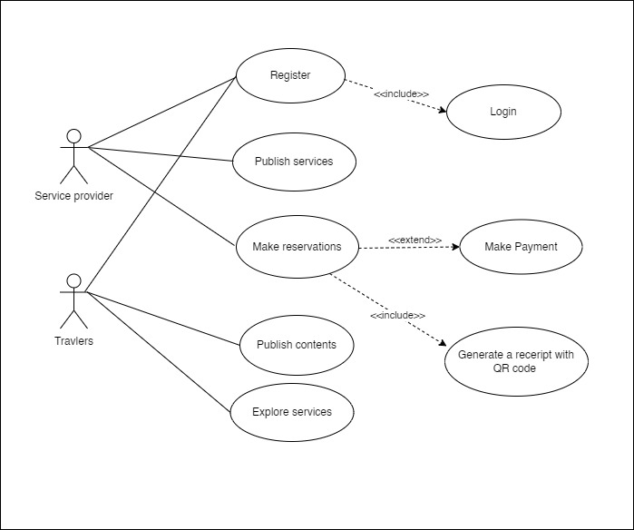

Figure Use case diagram

### 2.2 Clear problem definition

Planning a trip can be a complex process depends on the type people involved and their interests. The process involves numerous tasks, such as searching and selecting a destination, arranging transportation, finding suitable accommodations, organizing food arrangements, and planning day-to-day activities throughout the trip. Many individuals are hesitant to get involved in the planning process because the ultimate goal is to satisfy all co-travelers and their expectations. Those who are often stressed or busy may view a trip as an opportunity to relax and unwind.

### 2.3 User stories

User stories are a technique used in agile software development to capture and communicate requirements from the perspective of the end-user. Each user story describes a feature or functionality that the user wants to achieve and follows a simple template: "As a [user], I want [feature], so that [benefit]. [23]"

**Service provider**

* As a service provider, I want to add my services to the system, so that the travelers can explore them and reserve them and that will help to grow my business.
* As a service provider, I can add, edit or remove the published services.
* As a service provider, I want to generate a report of the reservations.

**Traveler**

* As a traveler, I want to explore the services as per my requirements and find the most suitable one.
* As a traveler, I want to reserve the required services to fulfill my travel needs.

### 2.4 SWOT Analysis

|  |  |
| --- | --- |
| **Strength** | **Weakness** |
| * Brand recognition establishment for the businesses. * Diverse range of travel offerings and packages * Strong partnerships with hotels, airlines, and other travel-related companies * Convince of travelers on finding related services. * Save time and misleading by the fraud guiders. | * Limited geographic reach or scope of services * Limited differentiation from competitors * Competitor pricing |
| **Opportunities** | **Threat** |
| * Expanding the business to reach more audience from new geographical locations * New and innovative ways to develop and reach the travelers. * Offering personalized and customized travel services to clients * Developing partnership with co-service providers and expand the business and brand recognition | * Competition from online travel booking platforms and price comparison websites * Fluctuating currency exchange rates * Changes in government regulations or travel restrictions * Natural disasters, health crises, or other unforeseen events that could impact travel demand * Increasing costs of travel-related services, such as fuel prices and hotel rates. |

Table -SWOT Analysis

### 2.5 Requirement Engineering

Requirement engineering is a process of eliciting, analyzing, specifying, validating, and managing the requirements of a software system. It involves understanding the needs of stakeholders, including end-users, customers, and business owners, and translating those needs into software requirements that can guide the development process.

The goal of requirement engineering is to ensure that the software system being developed meets the needs of its intended users and stakeholders. It involves a range of activities, including gathering and analyzing user needs, creating use cases, and defining functional and non-functional requirements [24].

#### 2.5.1 Functional requirements

|  |  |  |
| --- | --- | --- |
| **Id** | **Description** | **Priority** |
| FR1 | **Title:** Service provider/ Travelers Registration Requirements  Any anonymous user should see a “Register Account” button to register a user account.  When the user clicks the “Register Account” button, the application navigates to the Register Account page. The “Register Account” page displays a registration form with the required details:  Email address should be validated against proper email structure and existing emails. If the email doesn’t have the format user@domain.com, a validation message should be displayed which says, “Improper email address”, and if the email already exists in the system the error message should be “User with the given email already exists, please login.”  The “Submit” button must be disabled until all mandatory fields are filled and validated.  The email ID should be validated to avoid duplicating.  Travelers can create one account with one email address. And Travelers should create their accounts through the mobile app. | High |
| FR2 | **Title:** User registration  When the user clicks “Submit” on the registration page, the system should create a new user account and the service providers and travelers can login to the system.  Service providers can log in to the web portal and publish their services.  Travelers can login to the mobile app and explore their needs and services published by the service providers. | High |
| FR3 | **Title:** User Login  When an anonymous user visits the website, they can click on the login button to access the login page. On the login page, they will see a form with fields for entering their username and password. They can also see a login button and a cancel button. If the user clicks the cancel button, they will be taken back to the home page.  If the user enters an incorrect username or password and tries to log in, they will see an error message that says "Invalid username or password". If they enter the correct login credentials and click the login button, they will be successfully logged into the system and redirected back to the home page. | High |
| FR4 | **Title:** Common Site Layout  There are different layouts for the service provider which is a web application and a mobile application for the travelers.  Web application:   * Login Screen * Profile * Services grid * Create Service form * Reservation list   Mobile Application:   * Login screen * Profile * Feed * Services feed * Reservation options | High |
| FR5 | **Title:** Reservation  Traveler should be able to access all the services published by the service provider.  Traveler should be able to view each service in a detailed list. If the traveler wishes to reserve the service, should be able to click on “Book Now” button and reserve the service.  Once the traveler clicked the “Book Now” a dialog message should be popup and request the user to download the receipt.  On successful reservation the reservation details should pass to node.js web application and create a table with the details | High |

Table Functional Requirements

#### 2.5.2 Nonfunctional requirements

##### Performance Requirements

|  |  |  |
| --- | --- | --- |
| **Id** | **Description** | **Priority** |
| P.NFR1 | All images stored on the server file system must be encoded with WEBP file format and they must stay within 20KB and 100KB file size for optimal transfer. | HIGH |
| P.NFR2 | All CSS and JavaScript assets must be minified and bundled for optimal size. | HIGH |

Table Performance requirements

##### Privacy and Security Requirements

|  |  |  |
| --- | --- | --- |
| **Id** | **Description** | **Priority** |
| S.NFR1 | All usernames and other sensitive user information must be encrypted. | HIGH |

Table Privacy and security requirements

##### Software Quality Requirements

|  |  |  |
| --- | --- | --- |
| **Id** | **Description** | **Priority** |
| Q.NFR 1 | Source code should have a unit test coverage of above 90% | MEDIUM |
| Q.NFR 2 | It is advised that developers must implement features with testing in mind, therefore they may follow a suitable test-driven development methodology. | MEDIUM |

Table Software Quality Requirements

2.5.3 Feasibility Study

A feasibility study is the phase of looking into an idea, project, or business's viability or sustainability of the project. The research looks at whether there are sufficient and what is feasible resources to involve in to the project and whether the idea has the potential to make profit. Also, it will show caste the rewards for taking the chance to invest in the concept [25].

We have to look in how feasible below sectors are,

* Technical Feasibility
* Operational Feasibility
* Economic Feasibility
* Schedule Feasibility
* Legal and Ethical Feasibility

#### Technical Feasibility

The Leisure Diary project which contains and web application and a mobile application. The feasibility study evaluates the if the system will show is performance and functions as mentioned. Technical feasibility also includes evaluating the availability of skilled personnel, necessary equipment, materials, and infrastructure to carry out the project. And the ability to build the said products. The leisure diary web application will be built with the association of the technologies mentioned in the resource requirements. The Technical Feasibility evaluates how the technologies are used in collaboration with the required skills. Most of the technologies are free for to use, therefore it will save huge sum of the cost for the company when building the project. As an important factor that the technologies currently have used to build the Leisure Diary web application and the mobile application has the potential of enhancing the further and add new features. Finally, Technical feasibility assessment is an important element of a feasibility study, as it helps to ensure that the project can be executed efficiently and effectively to achieve the desired outcomes as mentioned above.

#### Operational Feasibility

Operational feasibility phase is used to evaluate the ability of the Leisure Diary to be implemented and delivered successfully in an operational perspective. In this phase Leisure diary were evaluated if the web and mobile applications are workable within the specified audience and achieve its said functions, goals and values. The operational evaluation also takes into account the influence of the project on the organization's current procedures and workflows. These elements include the availability of staff, the skills, and training needed to conduct the project successfully. The project's compliance with the organization's culture, regulations, and procedures as well as the availability and accessibility of resources like technology, infrastructure, and money are further considerations. Operational feasibility is important for establishing if a project or business endeavor can be carried out and sustained over the long term, and it influences stakeholders' decision-making greatly. Hence, analytics confirms that the Leisure diary can sustain on above requirements, can be conclude that the Leisure Diary project is operationally feasible.

**Economic Feasibility**

Planning is necessary for an organization to accomplish one of its primary goals, which is to expand and become profitable. The economic feasibility analysis is one of the most crucial elements in this process of investment selection and prioritization. In addition to establishing if a particular approach is profitable, this analysis seeks to determine whether it is economically viable or not. Since resources are limited and there are other financial priorities in the competition for investments with higher returns, it will be necessary to conduct a careful analysis before adding an initiative to the portfolio, even if it is creative, innovative, and can produce excellent results for some stakeholders. The economic feasibility analysis is a study that will compare the returns to be obtained with the investment required to point out its feasibility, being, therefore, an extremely important process, which brings business intelligence, avoids losses, and leads to more assertive decisions [26]. Service providers and customers can access the Leisure Diary from anywhere. They can signup and publish their services with no cost. From the companies end most of the technologies are free for to use, therefore it will save huge sum of the cost for the company when building the project. Only cost the company would be bearing the cost of hosting, developer salaries and the service payment for google cloud console.

Technical Requirements

Table Technical Requirements

|  |  |  |
| --- | --- | --- |
| Technical Requirements | | |
| Unit | Qty | Price |
| Personal Computer | 1 | 80,000 |
| Mobile Phone | 1 | 65,000 |
| Human Resource Requirements | | |
| Business Analysist | 1 | 50,000 |
| Web Developer | 1 | 80,000 |
| Mobile App developer | 1 | 80,000 |

Leisure Diary is planning to charge on a commission basis from the service provider and travelers as service charge from each service they render from the system. Hence, the business will grow as sooner the Leisure Diary get promoted.

#### Schedule Feasibility

A project can be implemented within a reasonable time frame if the schedule is feasible. If a project is not finished within its allotted time range, it may occasionally not be successful. Here, we can estimate how long it will take to accomplish each project activity. The Leisure Diary project can now be finished before it becomes superfluous or obsolete thanks to the schedule feasibility study. The Leisure Diary project's timetable viability was evaluated taking into account how time and money interact. The Leisure Diary project is expected to take 4 months to fulfill its many duties. Thus, the project schedule was determined to be feasible by taking into account the project activities and time need. The author has created a Gantt chart that details the project's many tasks and the time needed to finish each one.

#### Legal/Ethical Feasibility

Legal and ethical feasibility in software engineering refers to a software system's capacity to abide by relevant laws, rules, and moral guidelines. This includes making sure the system complies with all security, privacy, and intellectual property rules. To make sure that the system does not hurt its users or other stakeholders, ethical factors including fairness, openness, and accountability must also be taken into account. Due to the potential for negative legal and reputational repercussions for the firm, legal and ethical feasibility is essential in software engineering. In order to guarantee that their software systems are conceived, created, and maintained in compliance with applicable laws and ethical standards, software developers and engineers must be aware of legal and ethical factors [27]. By having confirmed that, the Leisure Diary website would not have to face any legal issues.

While studying the legal and ethical requirements, the privacy, nepotism, and accountability were considered as well. Leisure Diary utilizes freely available development tools, and provide the system as an open-source system. Only the service commission will be charged from customers and service providers. Software libraries that are utilized in this system are free open-source libraries. Hence, the author concluded that the Leisure Diary project is legally and ethically feasible.

### 2.6 Resource requirements

|  |  |
| --- | --- |
| Software requirement | * Visual Studio code editor * Windows 7 or above * MongoDB/Firebase * Android studio |
| Hardware Requirements | * Personal Computer * 8GB RAM or higher * 500GB HDD * 1GB Video Graphics card or Higher |
| Client requirement | * Mobile phone with internet connection * A PC with internet connection |
| Technological requirements | * HTML * CSS * JavaScript * Flutter * MongoDB / Firebase * EJS |

Table Resource requirements

### 2.7 Outcome of the analysis

The requirement elicitation is the primary objective achieved by the analysis process. User stories and use case diagram assisted to get a clear picture of the actual scenario and to identify the flow of the system. Clear problem identification phase helped to elaborate the actual problem and align it with the requirement identified in the early phrases. Along with that we have conducted a SWOT analysis which is the best way to identify Strengths, Weakness, Opportunities, and Threats in the related field and forecast the future. As a summary of the requirement elicitation, we have finalized the functional requirements and non- functional requirements to implement the system.

# 3. Design

## 3.1 Design Techniques

Design is the highly creative and important stage in software development process. Design process will be held iteratively through entire development process in different number of ways. A good system design will arrange the program modules so that they are simple to create and modify. Developers can manage the size and complexity of programs with the aid of structured design strategies. The developers are given guidance by analysts on how to write code and how to put parts of code together to create programs. The process of developing, creating, testing, and maintaining software is known as software engineering. The creation of software that is dependable, effective, and simple to maintain is the aim of software engineering. Making choices about a software system's architecture, components, modules, interfaces, and data is a crucial aspect of system design in software engineering.

### 3.1.1 Flow Chart

A flowchart is a visual representation of a process or algorithm using various symbols and shapes to show the sequence of steps and decisions involved. It is a useful tool for understanding and documenting complex processes or systems. Each symbol in a flowchart represents a specific action or decision point in the process, and arrows connect the symbols to show the flow of the process. Flowcharts are used in a variety of fields, including software development, engineering, and business. They help to simplify complex information and make it easier to understand [28].

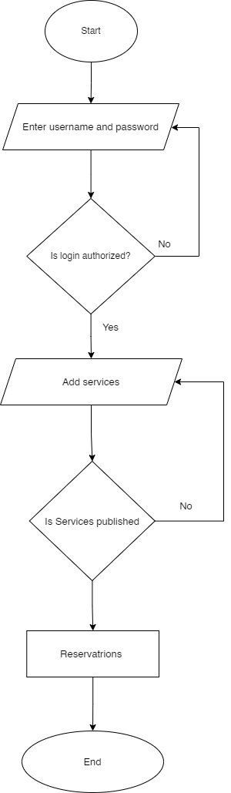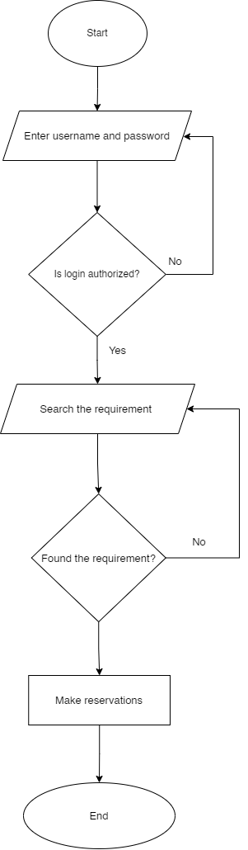

Figure Service provider Flow chart

Figure Travelers flow chart

### 3.1.2 Use Case Diagram



Figure - User case diagram

### 3.1.3 ER Diagram

An Entity Relationship Diagram (ERD) is a type of flowchart that illustrates the relationships between entities such as objects, people, or concepts in a system. ERDs are often used to design and debug relational databases in various fields such as software engineering, business information systems, education, and research. These diagrams use a specific set of symbols, including diamonds, rectangles, ovals, and connecting lines, to represent the interconnectedness of entities, relationships, and their attributes. ERDs follow a grammatical structure where entities are represented as nouns and relationships as verbs. The main purpose of an ERD is to show the infrastructure of the entity framework, as illustrated in the example of the leisure diary project.

### 3.1.4 High Level System Component Diagram

Figure ER Diagram

Below is the high-level structure of the application. The backend consists of a REST API coupled with two databases. A HTTP port and a TCP port is exposed for external communication interfaces. WebSocket communication shares the same HTTP port.

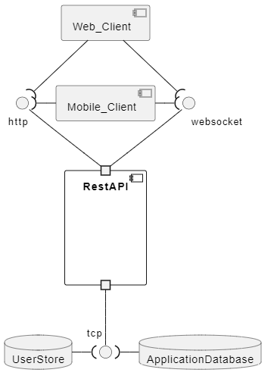

Figure System component diagram

### 3.1.5 Data Flow Diagram

Data flow across a system is shown visually in a DFD (Data Flow Diagram). It is frequently used for information system analysis, design, and documentation. Below is the illustration of Leisure Diary’s Level 0 Data Flow Diagram which describes the scenario including web and mobile applications:

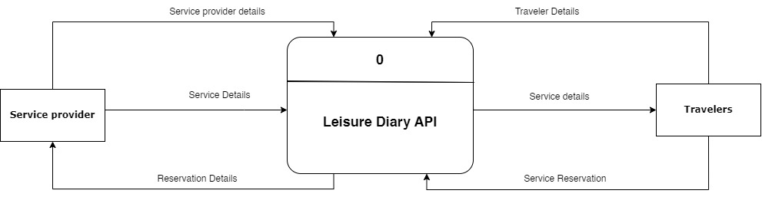

Figure - Data Flow Diagram Level 0

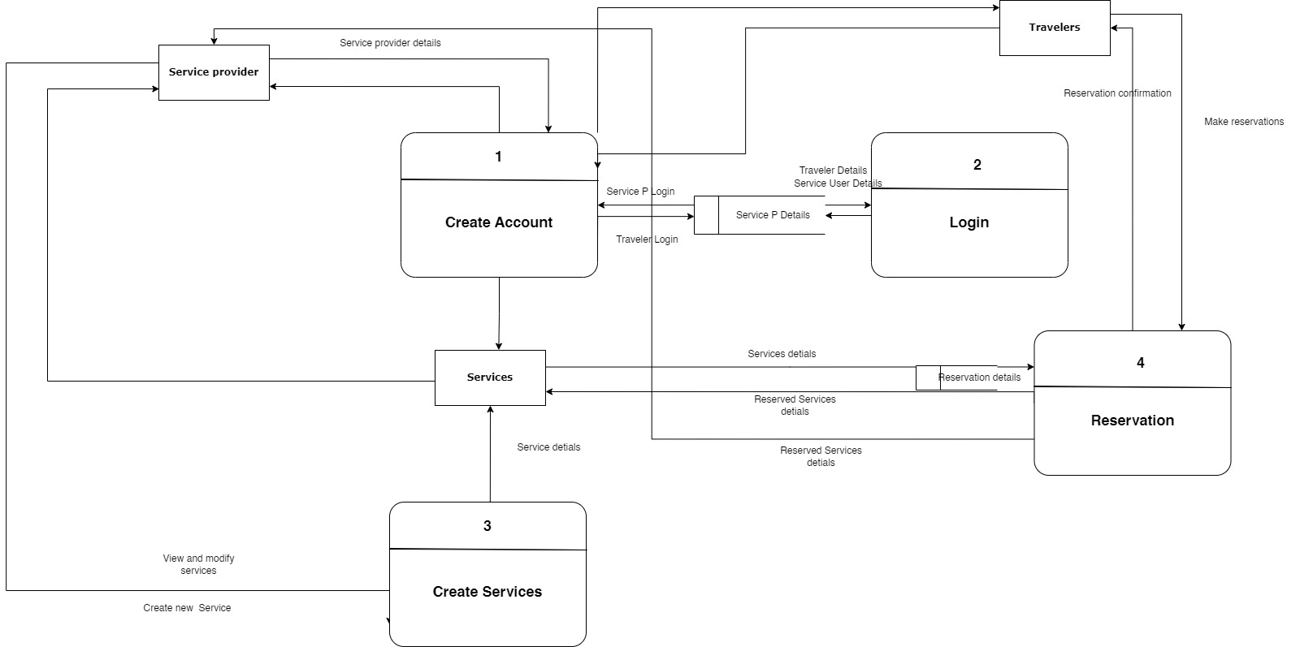

Figure - DFD level 1

### 3.1.6 Class Diagram

A class diagram in the UML (Unified Modeling Language) is a form of static structural diagram used in software engineering that depicts the classes, properties, operations (or methods), and interactions between objects to represent the structure of a system. The class diagram created to create the Leisure Diary Web & Mobile application is shown below.

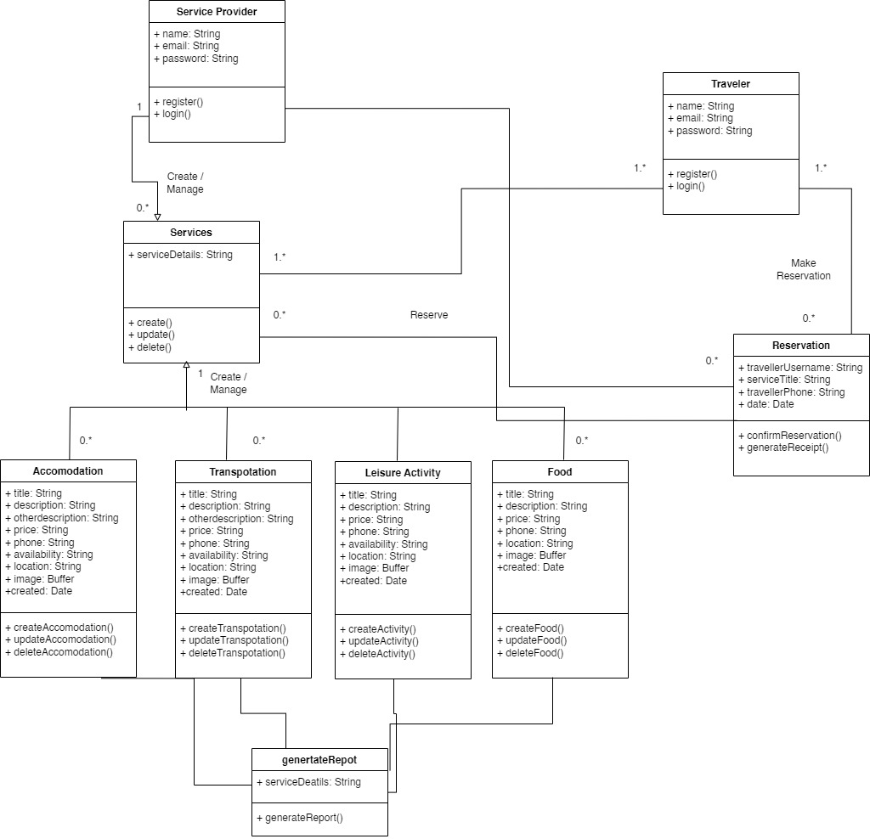

Figure - Class Diagram

### 3.1.7 Activity Diagram

A sort of Unified Modeling Language (UML) flowchart called a "activity diagram" depicts the progression of one activity across a system or process. It is referred to as a "behavior diagram" because it outlines what ought to occur in the modeled system and is used to depict the various dynamic characteristics of a system. Activity diagrams can be used to visualize even extremely complicated systems. As a result, activity diagrams are frequently employed in organizational business process modeling or to outline the processes of a use case diagram. They display each step in an activity along with their relative timing. They can also display the data flow between several activities [29].

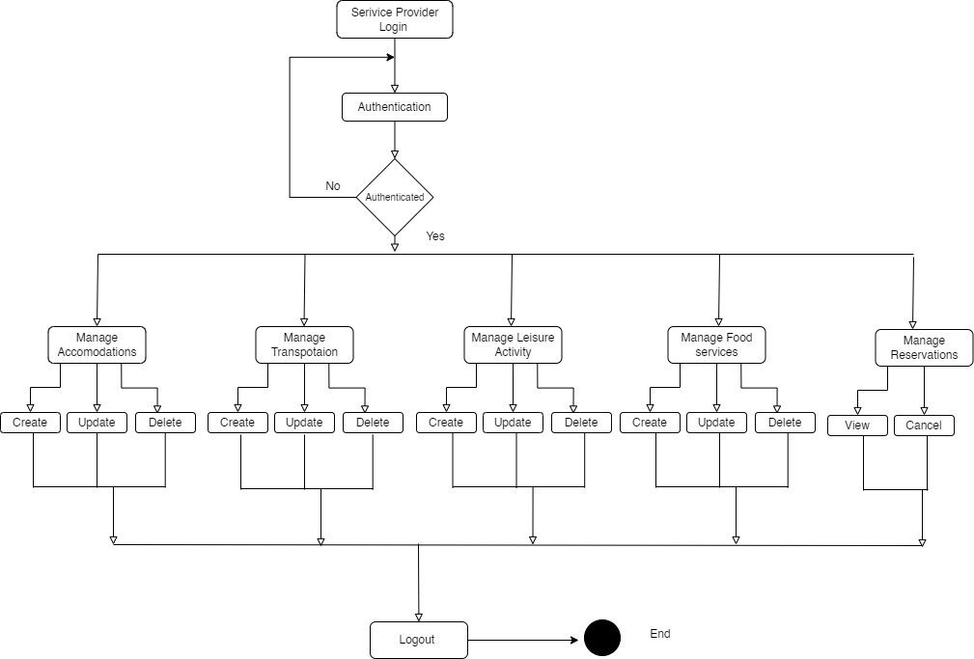

Figure - Service provider Activity Diagram

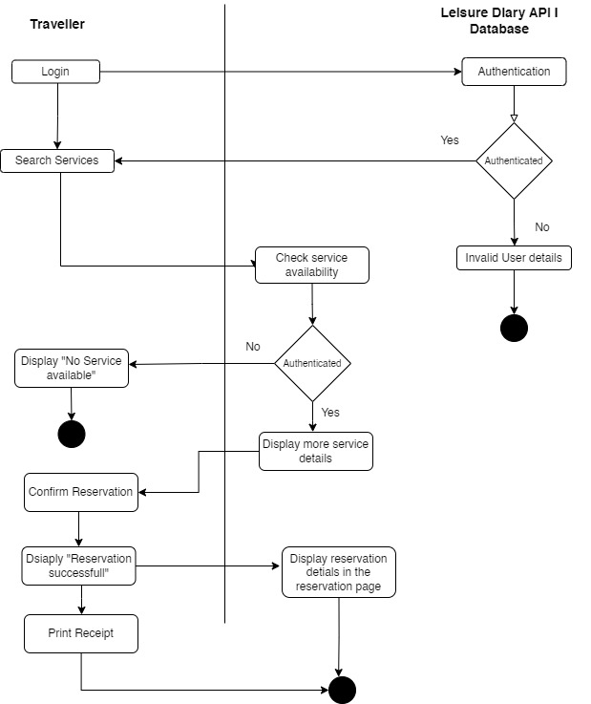

Figure Traveler Activity Diagram

### 3.1.8 Sequence Diagram

A sequence diagram is a diagram created using the Unified Modeling Language (UML) that shows the flow of messages sent and received by objects during an interaction. A group of objects that are represented by lifelines and the messages they exchange over the course of an interaction make up a sequence diagram [30].

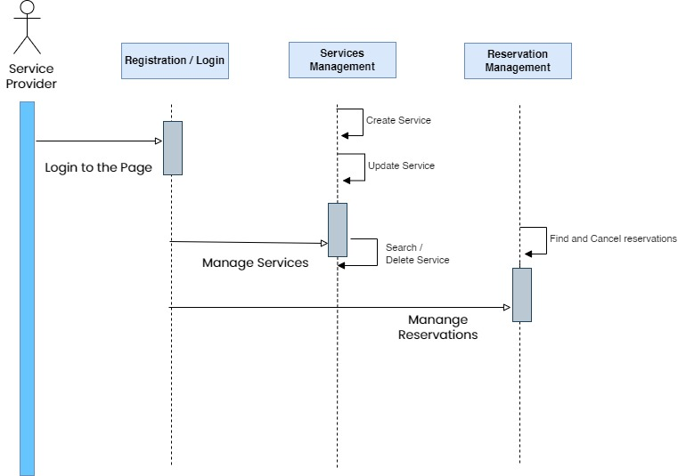

Figure Sequence Diagram service provider

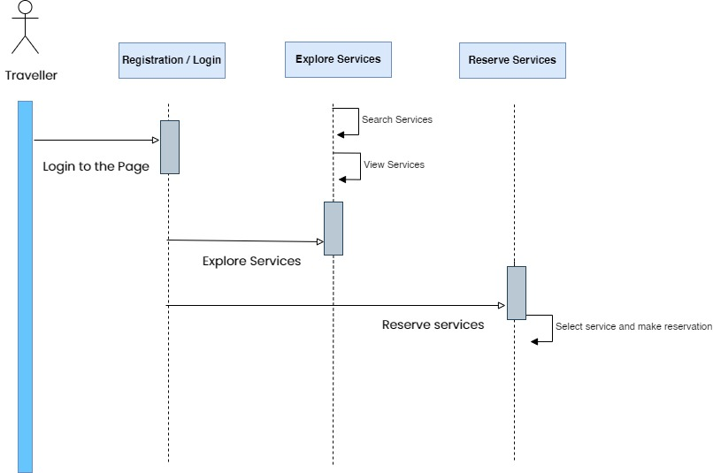

Figure - Sequence diagram - Traveller

## 3.2 System Overview

Leisure Diary is the proposed solution for the identified significant problems and requirements addressed by the travelers and other service providers. The solution is a web based mobile application connected to an admin panel through a rest API technology. Application will have many entities such as Location accommodators (Hotels and resorts), transport providers, foods, other restaurants and other leisure activities. The solution is like a story creator which attracts the user’s interest with going forward with the application.

A user can register to the application by creating an account. The story begins the user can start to create the travel package. User can base locations, type of foods/restaurants or leisure activities as the initial point of selection. The application shows recommendations based on your interest. With adding the no. of people to the system it filters the available options to proceed. After creating the whole story of the trip, you can share it among your co-travelers and other service providers on their approval of the reservations.

### 3.2.1 Wireframes

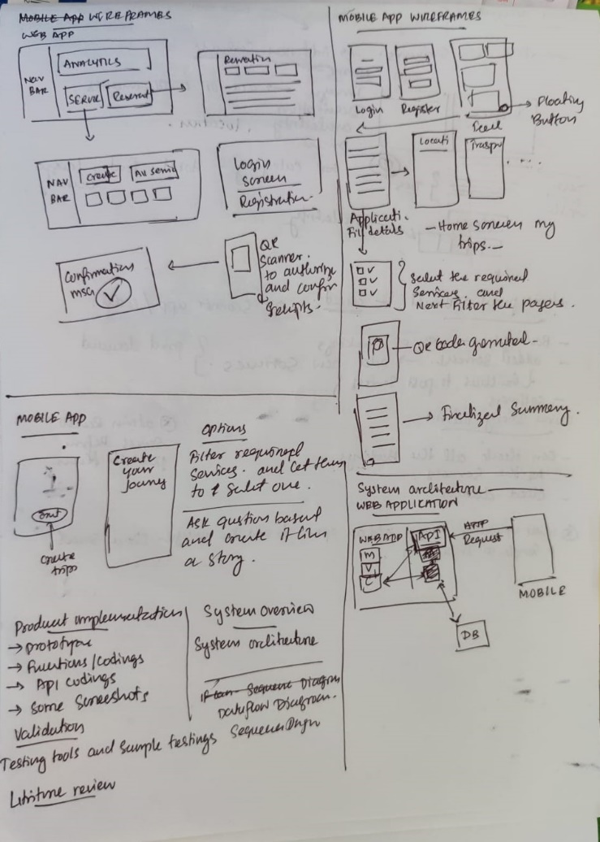

Figure Wireframe Sketch

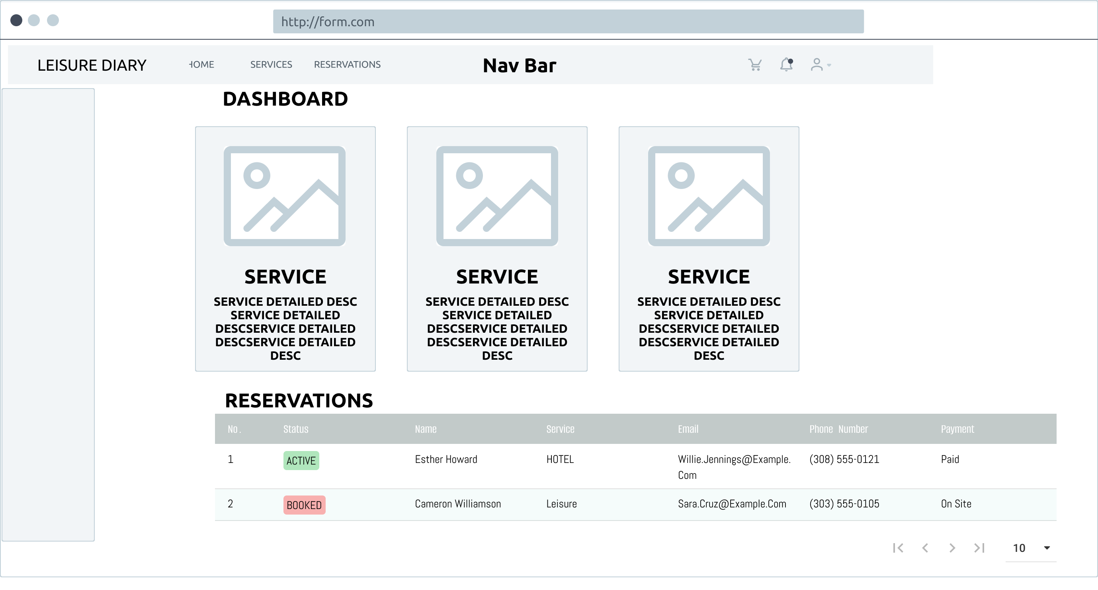

Figure Wireframe

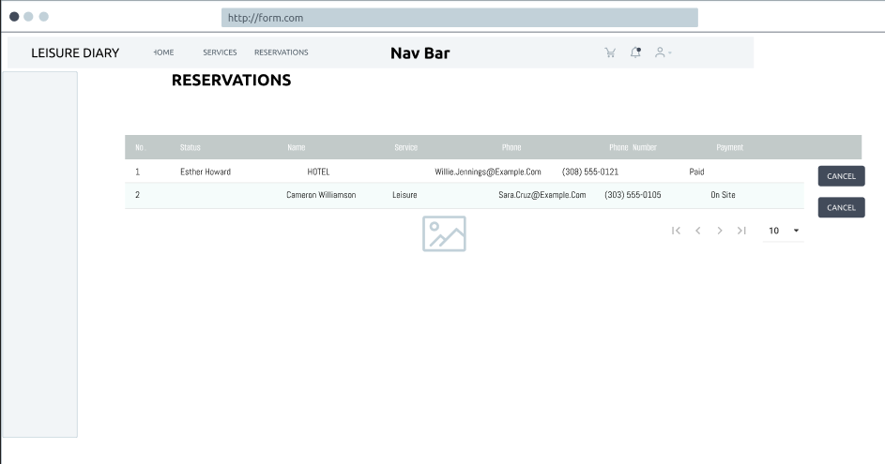

Figure Wireframe

Figure Wireframe

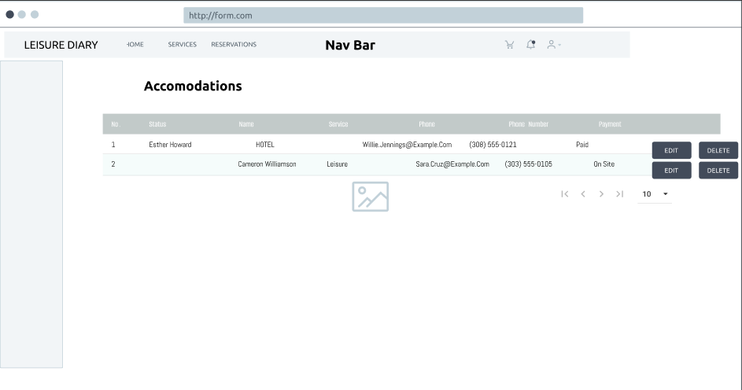

Figure Wireframe form

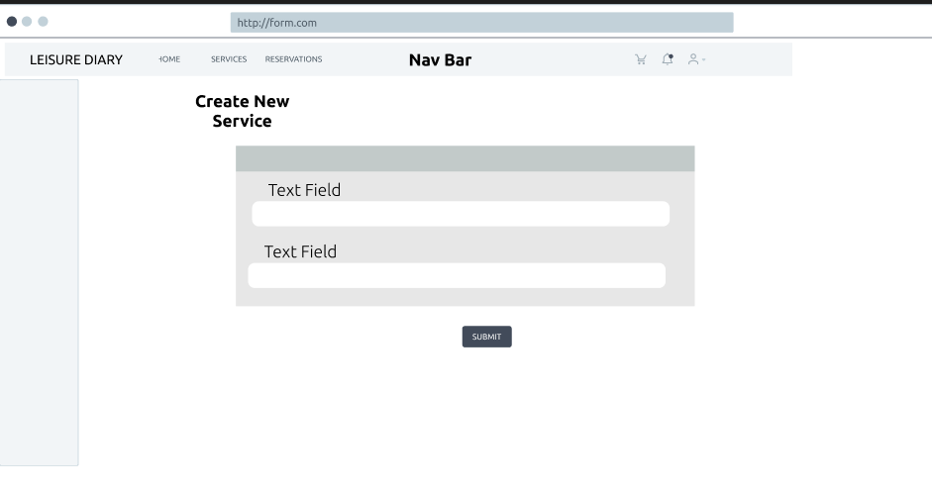

**Mobile App wireframes**

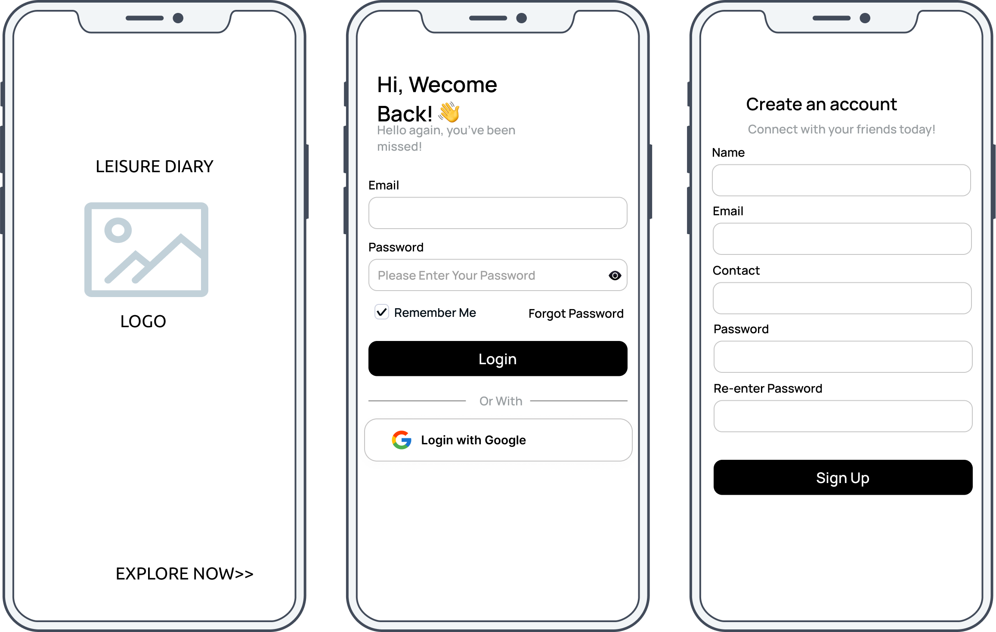

Figure Wireframe

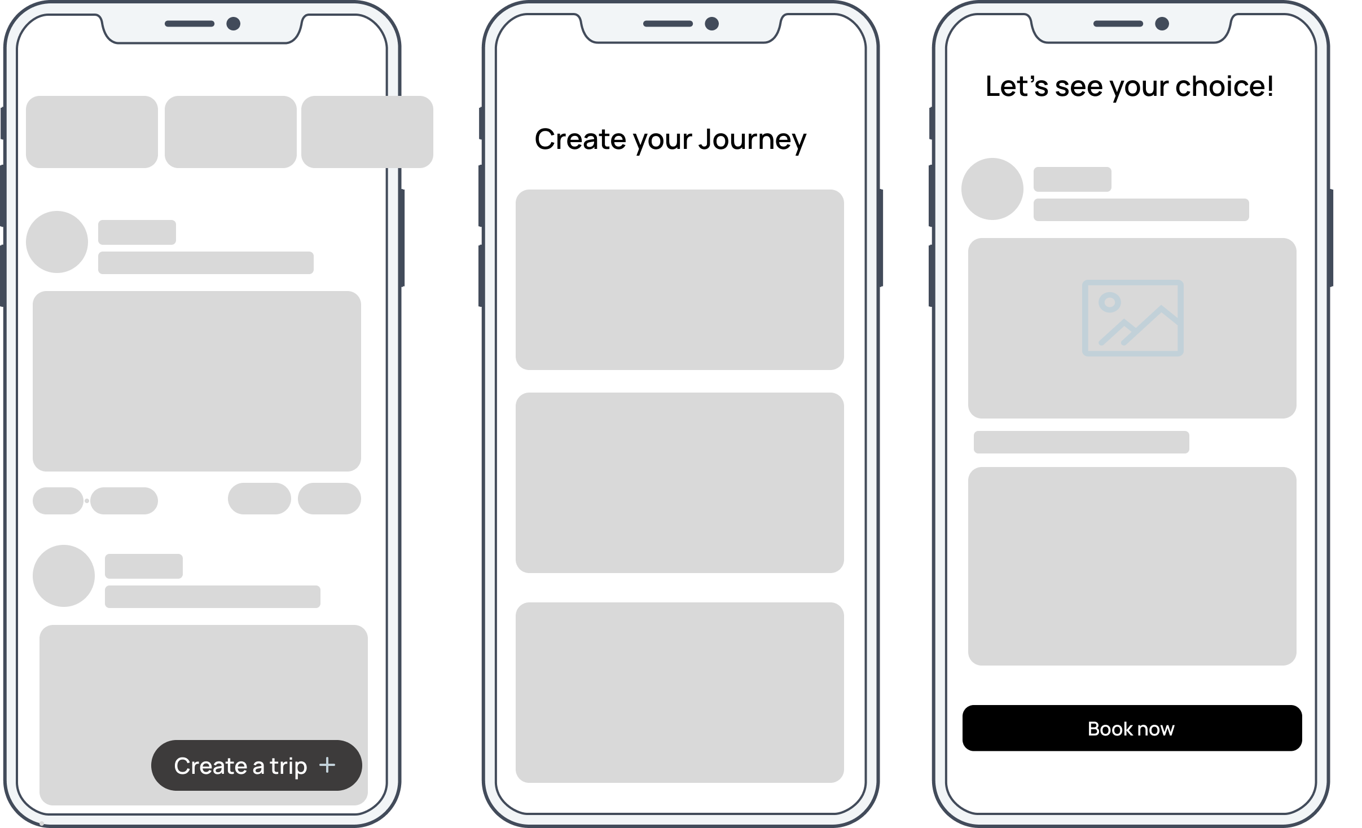 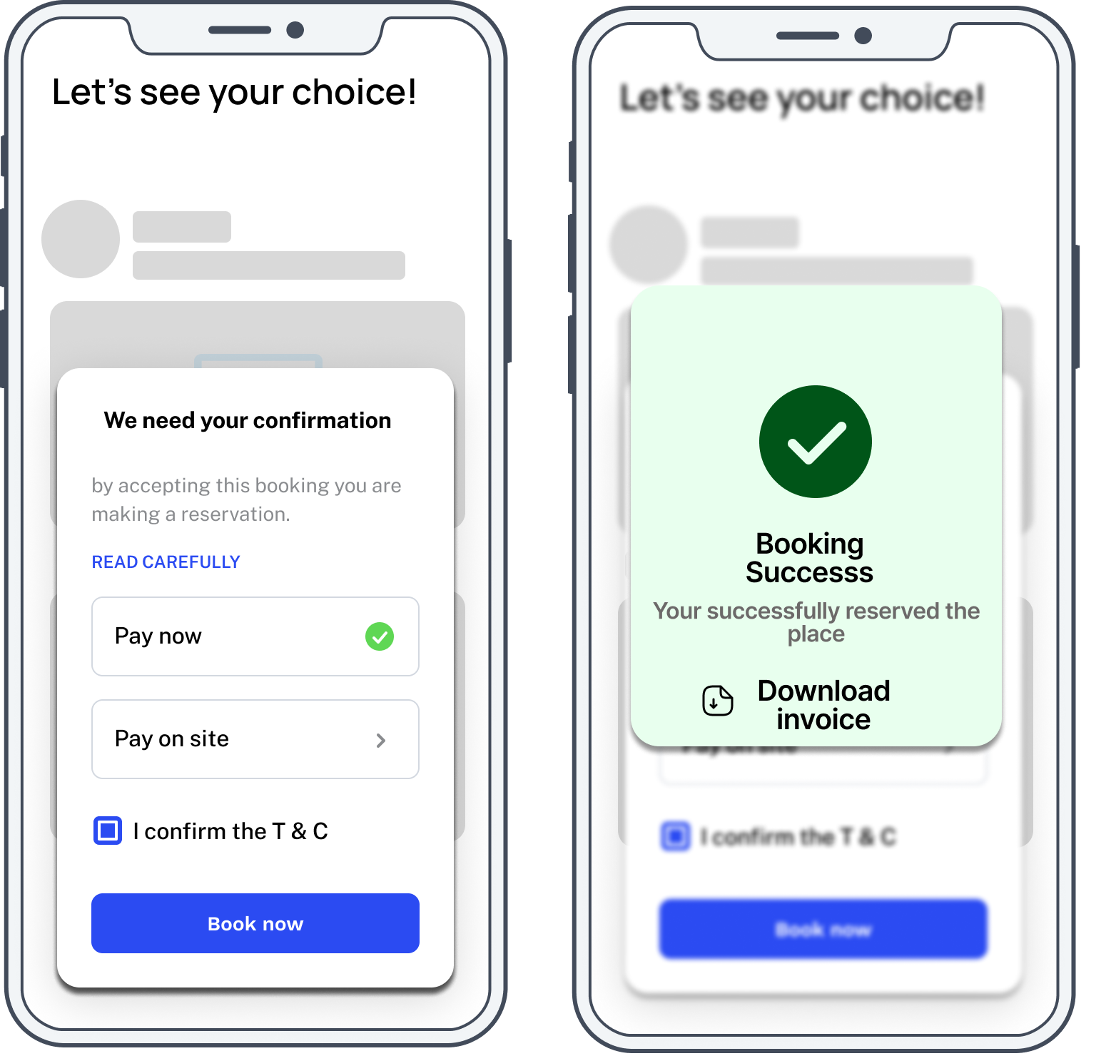

### 3.2.2 System Architecture

The design of a complicated system that consists of hardware, software, network infrastructure, and other components is referred to as system architecture. It aids in ensuring that all parts perform properly by defining a system's structure, behavior, and functioning.

The system architecture is crucial because it gives stakeholders a high-level picture of the system and makes it possible for them to comprehend the connections and interactions among various components. Making wise decisions about trade-offs between cost, performance, and usefulness is made easier by early identification of potential problems and hazards [31].

As it indicates in the below architecture the web application creates the data and store it to an API which will be saved in the DB. The REST API will be used to communicate with the mobile application. API can directly access the model and the services of the web application and save the changes to cloud database.

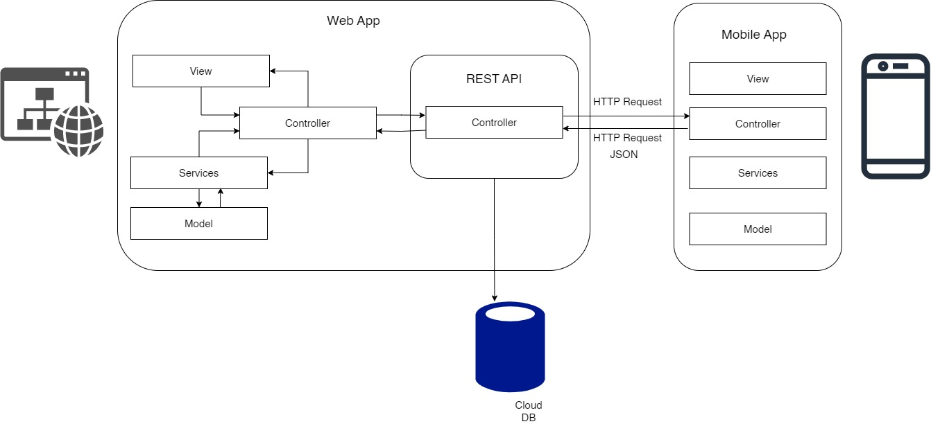

Figure System Architecture

The system architecture of the Leisure Diary for web application and mobile application show cast the front-end interfaces are developed using the languages; HTML, CSS, and JavaScript and flutter for the mobile application. The users of the Leisure Diary system are able to manipulate data using the front-end interfaces of the web & mobile application.

MVCS architecture has been used to implement the leisure land web application. The model-view-controller-service (MVCS) design adds a service layer to the conventional MVC paradigm. This architecture encourages a modular method of web development, in which various components are divided according to their function. The Model is used to retrieve, store, and change data and is in charge of the application's data and business logic. The View, which can be any kind of user interface, such as a webpage, a mobile application, or a desktop program, is in charge of showing the user the data. The Controller manages user input, converts it into actions, and manages the application's flow [32].

### 3.2.3 Actual Design

Actual Design contains two main applications as mentioned above. One is the web application which is used by the service provider to sign up and manage services.

#### Leisure Diary website

Leisure Diary has a web site where the user can search and land to the site. Site has Navigation panel with the links Home, About, Services, Blog and Contact form, where the visitors can quickly navigate to the particular page. Also, the user can create new account using Sign Up button and returning user can log in to the page using sign in button which has been displayed on the Nav bar.

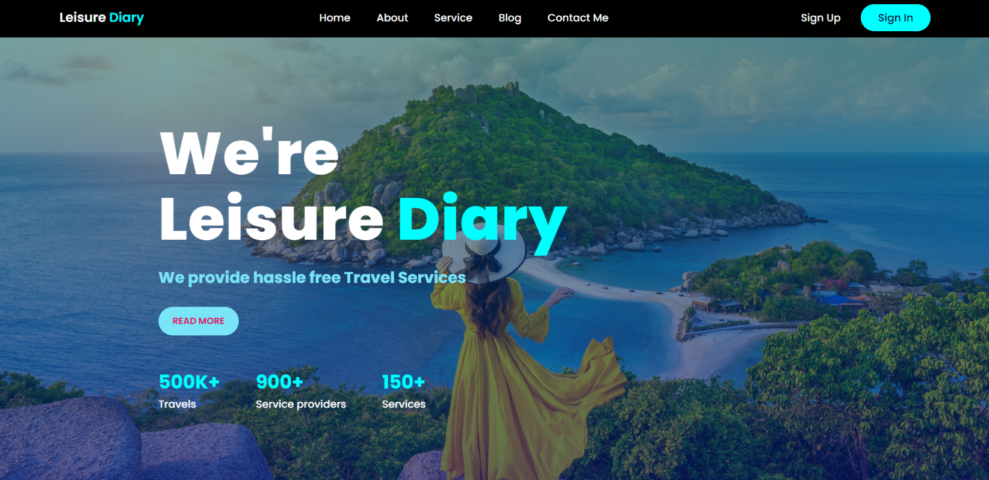

Figure Leisure Diary website

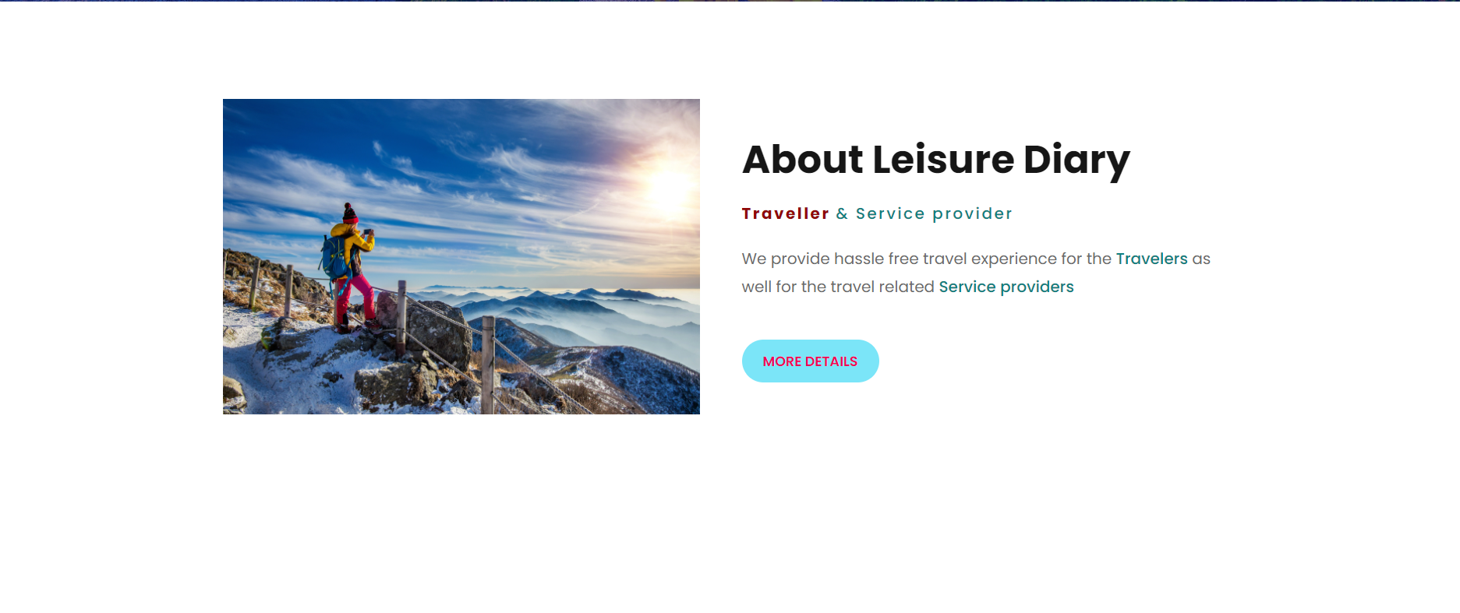

Figure Website about page

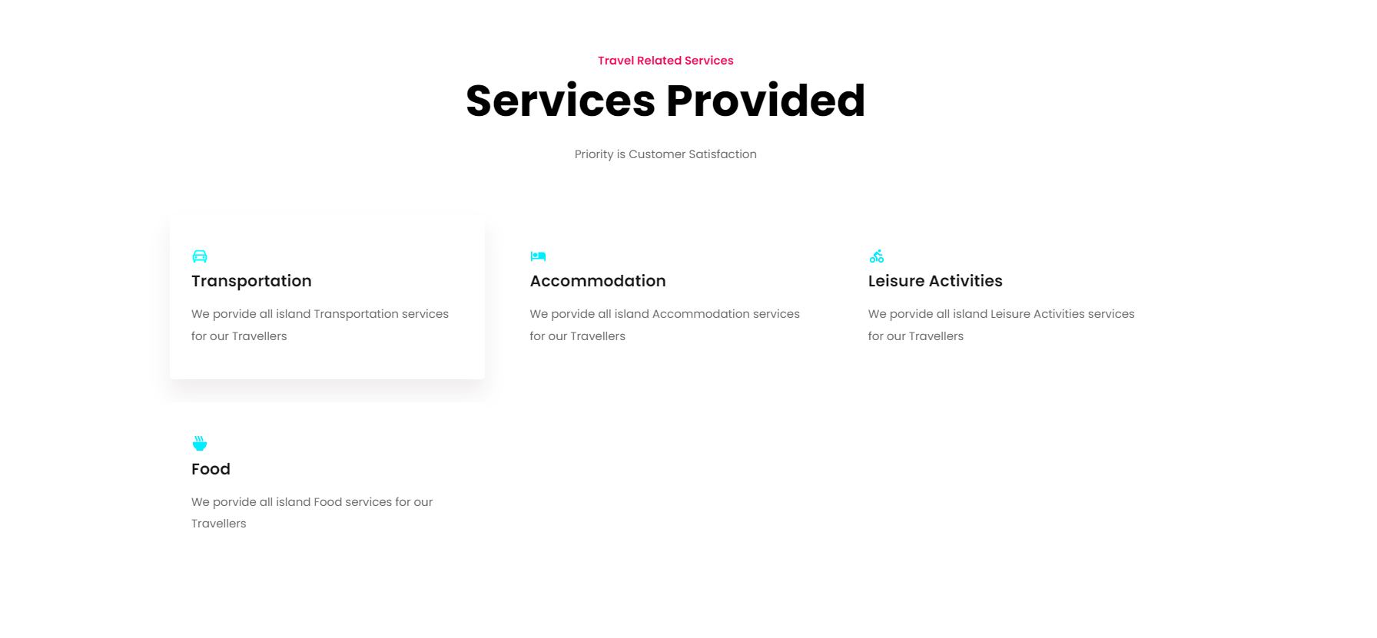

Figure Service details page

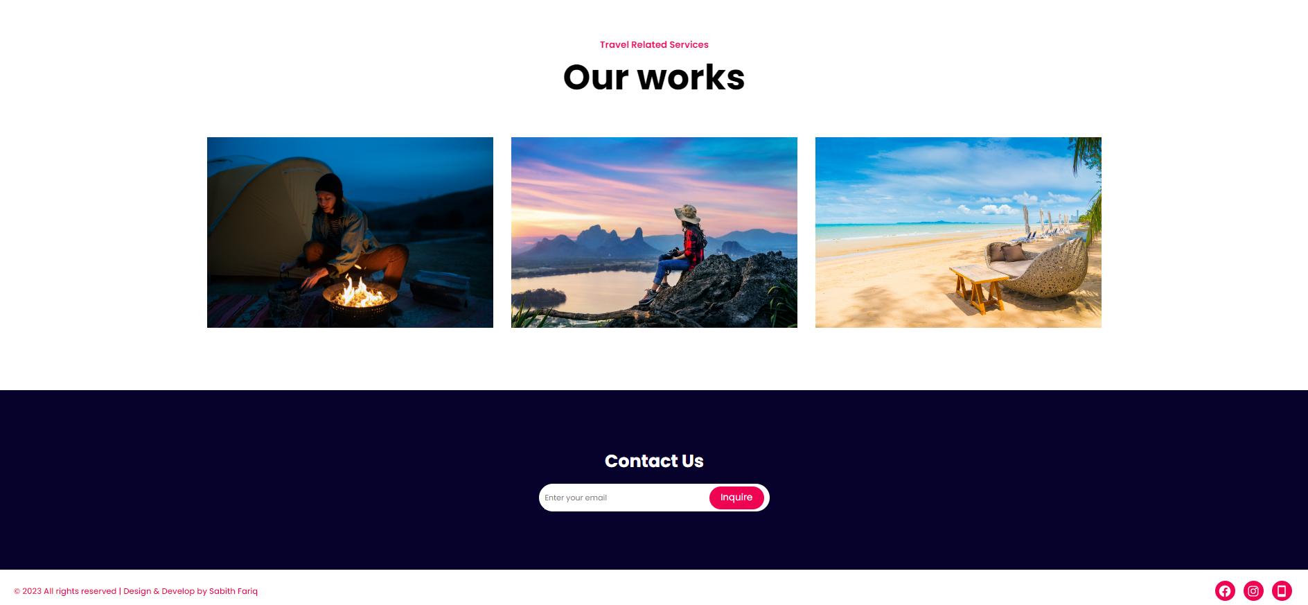

Figure Our Works

**Login Screen**

A user will redirect to this login screen when they click on the sign in button in the website. User can use their username and password to authenticate their self to log in to the dashboard.

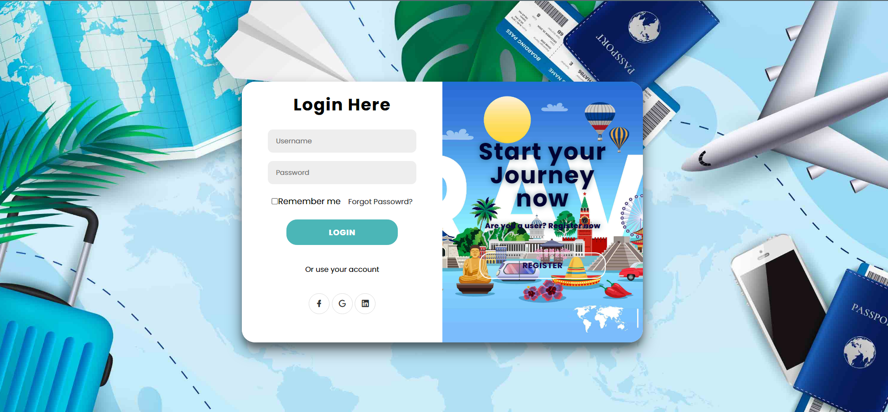

Figure Login Screen

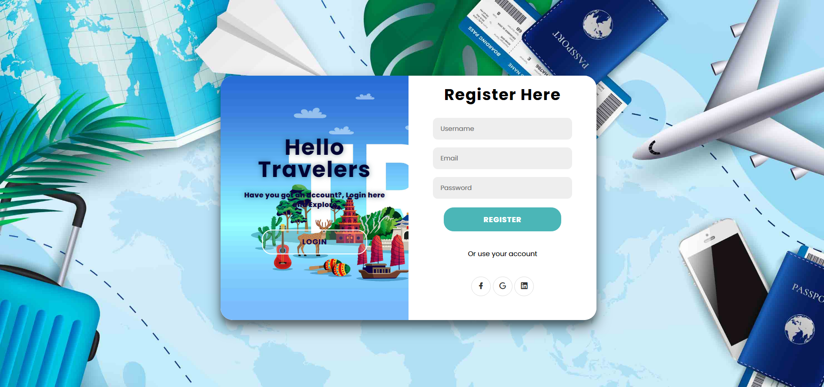

Figure Registration page

User can provide their desired username, email and password to create new account. Password will be bcrypted and saved in the database. User can use the username and password to login to the system Dashboard.

#### Dashboard

User will be navigated to the dashboard once they authenticated from the login screen. Dash board has the available Services as cards. And the Links to each services.

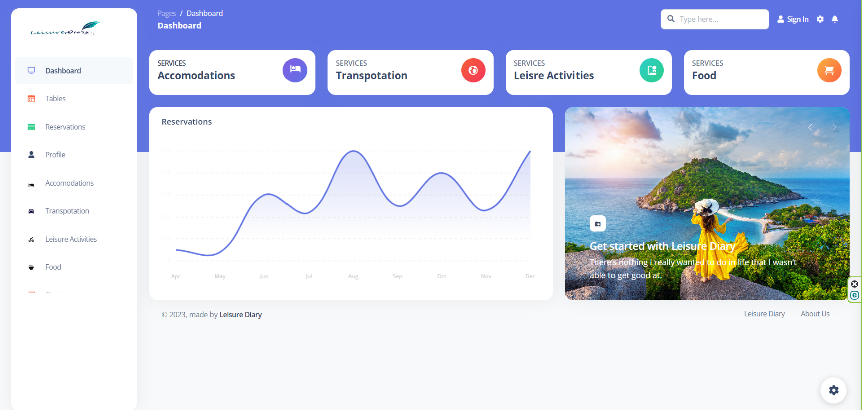

Figure - Leisure diary dashboard

**Accommodations Dashboard**

Accommodation dashboard will be empty when the new user got registered. It shows no services found as in the below snippet.

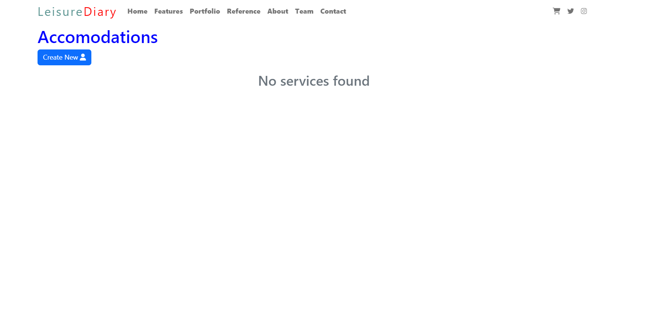

Figure - Accommodation Dashboard

**Create new accommodation**

Once we click the “Create new service” button a form will be displayed and all the details must be entered. Fields are validated against being null.

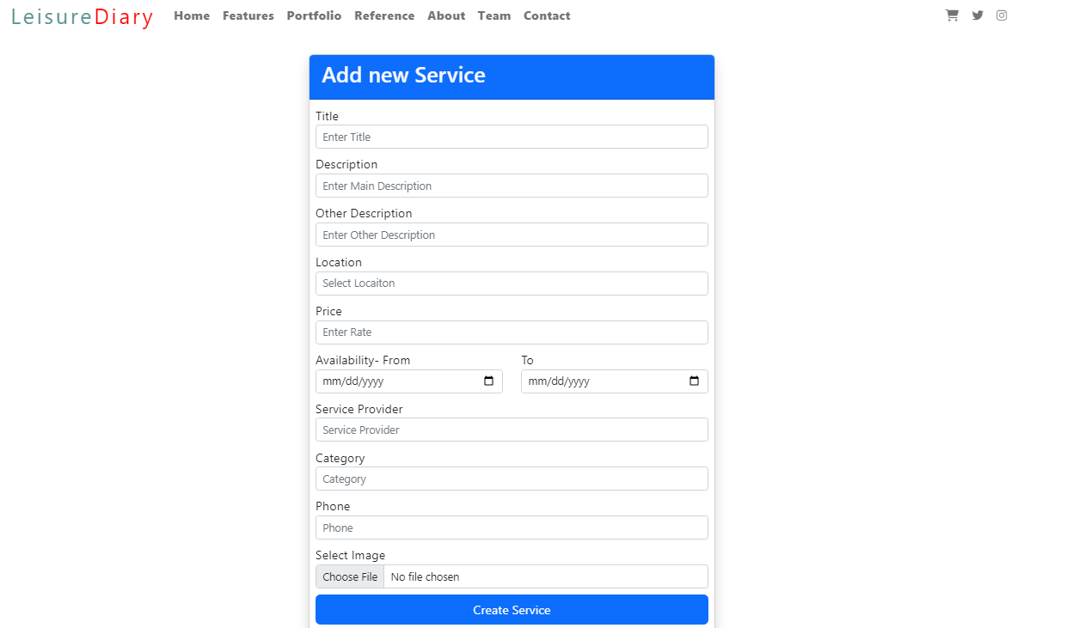

Figure Service creating form

Figure 38- Success message

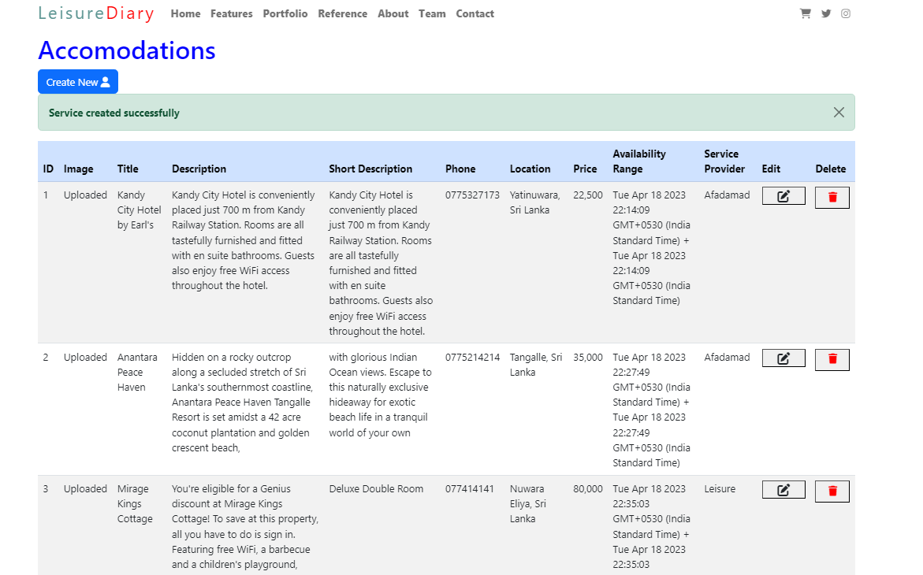

Figure - Accommodations Dashboard

Transportation Dashboard

Create new Transpotaion

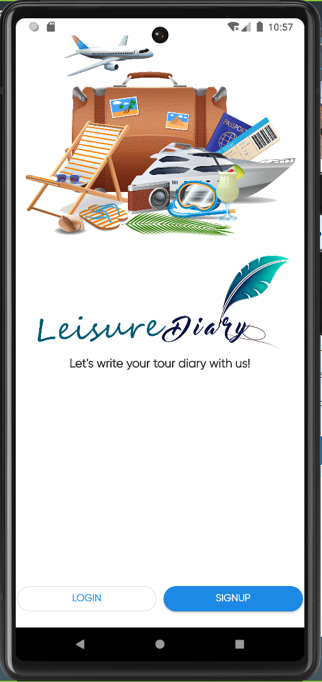Reservation Table

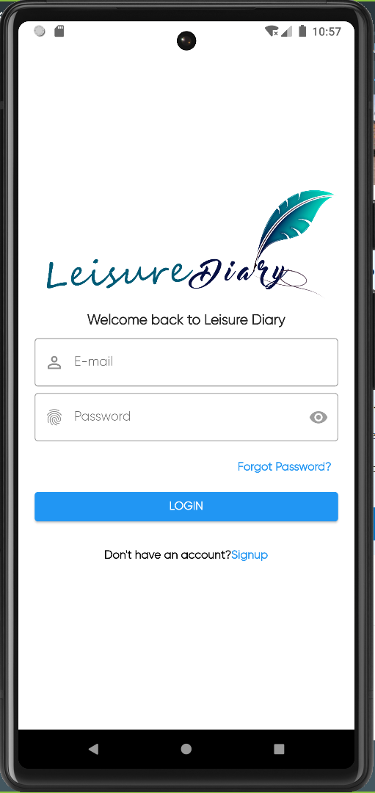

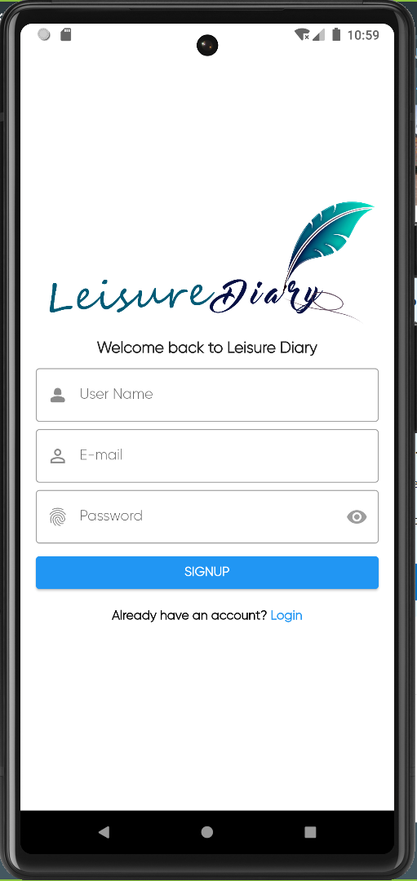

**Home Page**

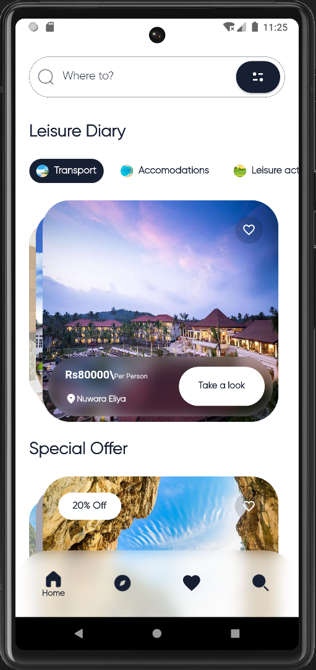

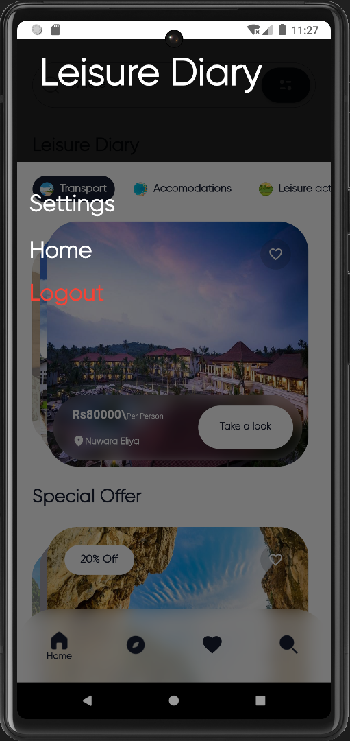

**Accommodation Page**

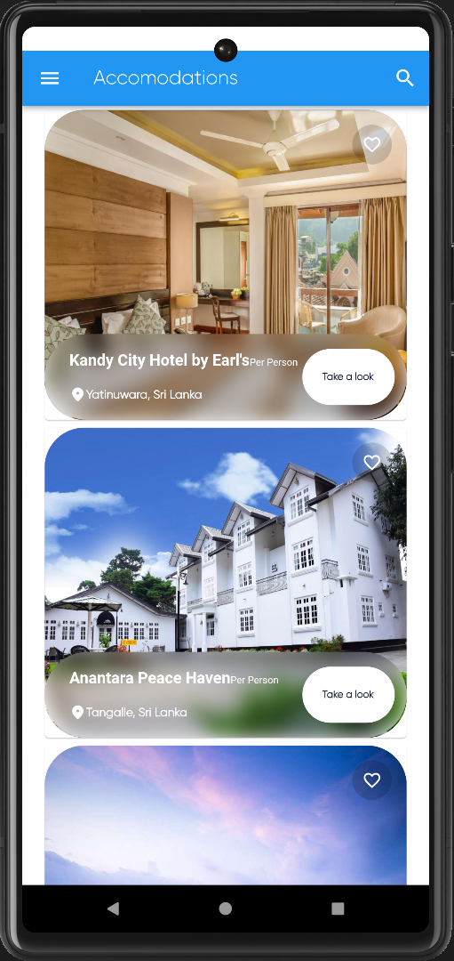

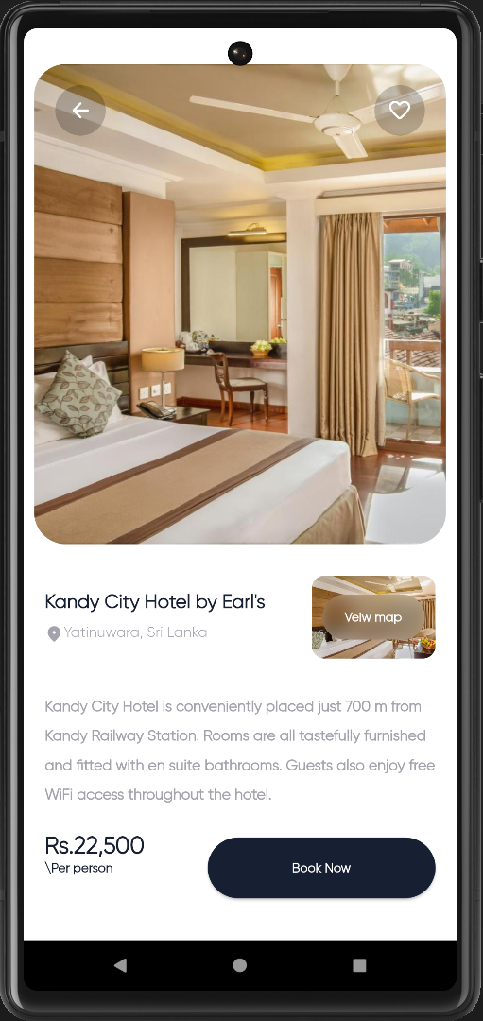

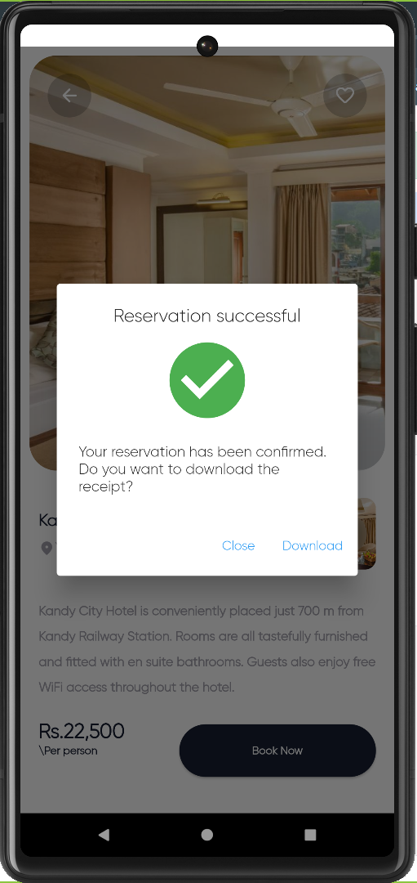

**Reservation table after its confirmation by the traveler**

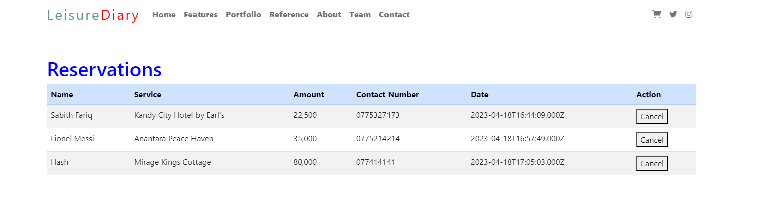

**Coding Snippets**

**Web Application**

##### Node.js Server configuration



Figure Server Configuration



Figure Server configuration 2

##### Database Configuration

Leisure Diary system has been used MongoDb as its database.



Figure DB connection

##### DotEnv file configuration



Figure DotEnv file

##### User registration

Figure Service provider login authentication

JWT tokens have been used to save the session in as a token. JWT is used to generating and validating secure tokens in web applications, or JSON Web Tokens. Users are authenticated using JWTs to grant access to restricted resources.



Figure - User Login

##### Service provider Model



Figure Service provider model

##### Traveler Login and registration

API end point for the travelers to sign and sign up using the mobile application. Leisure diary mobile application has no separate database. It will post all the data the API hosted via Node.js backend. API will do all the communication between the mobile application and the database.



Figure Traveler model



Figure Traveler model

#### Service Models

##### Accommodation Model





Figure Accommodation model

##### Transportation service model





Figure Transportation model

##### Leisure Activity model



Figure Leisure Activity model

##### Food Model



Figure Food Model

##### Routing libraries



Figure Routing libraries

#### Service routing codlings

The coding part of the services is divided in to a few categories and hosted in to separate endpoints. End points have been created to Get, Create, Update, Delete and Transfer in to API.

According to the specific endpoints client-side pages will be rendered.

##### Routing codes to get data from the Database



Figure Accommodation Get method

**Transportation Get method**



Figure Transpotation get method



Figure Leisure activity GET method



Figure - Food Get method

#### Service posting routes



Figure Posting routes







Figure Post routing

**Front end page rendering on routing**



Figure Front-end page rendering

##### Update routing



Figure Update routing

##### Delete routing



Figure Delete routing

Reservation codings

Mobile application codings

# 4. Product Implementation

As we identified through requirement elicitation, a web app and a mobile app are to be created and connected through a REST API. The decided technologies that are to be used when implementing the web application are ExpressJs which a frame work of Node.Js to build the back end and HTML, CSS and JavaScript have been used to frontend of the application. To save more time when building the frontend, a templating language EJS (Embedded JavaScript) has been used. It will make the code look simply, reduce the developing time, speedy execution, easy debugging and active development. Also, to avoid the code being more sophisticated to understand we have refactored the code into separate folders as per the MVC Architecture. By using expressJs the REST API endpoints have been created to communicate with the mobile application and being saved in the mongoDb database which is a cloud Database. Also, the system will be utilizing the object-oriented programming (OOP) concept in order to organize and manipulate the objects in the web application and mobile application.

**Manual Test Cases**

**Test case #:** 1

**Module**: Database Connection

**Component**: Database Connection

**Scenario**: When the server starts, server should automatically connect to the DB and console should print “Mongo DB is running with its token”.

**Preconditions**:

1. Cloud database connected to the IP.

**Expected Results**:

1. Database automatically connects to the server.
2. Console should print “Mongo DB connected successfully”.

**Database connection implementation**



Figure Testing

Figure DB connection code

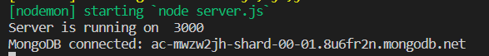Figure Test case

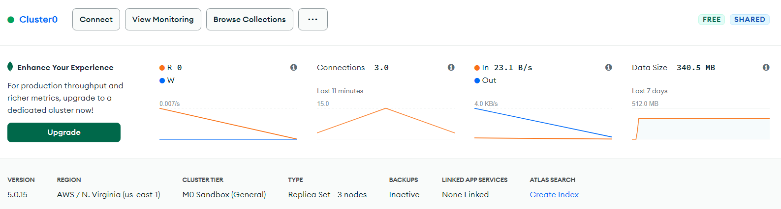

Figure MongoDB connection

**Test case #:** 2

**Module**: Database Connection

**Component**: Database Connection

**Scenario**: When the server failed to connect to the Database.

**Preconditions**:

1. Cloud database connected to the IP.

**Expected Results**:

1. Database automatically connects to the server.
2. Console should print error message.

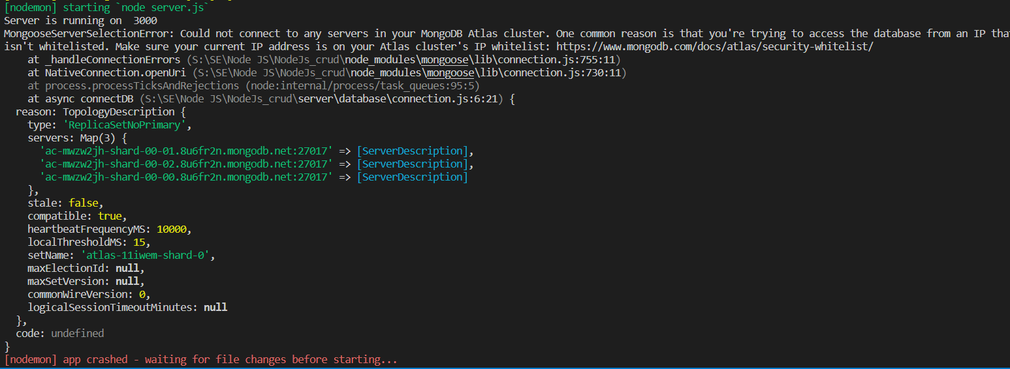

Figure DB connection 2

**Test case #:**

**Module**: API Connection

**Component**: API Get

**Scenario**: When we send a Get request to the route “/” it should return the status code “200”.

**Preconditions**:

1. Server and API up and running.

**Expected Results**:

1. Status code 200.
2. All the data from API body.

**Output**

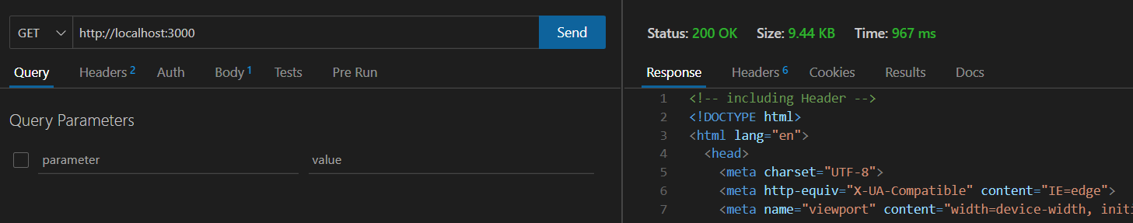

Figure - API testing

# 6. Critical Review & Conclusion

## 6.1 Closing executive summary

In conclusion, the development of our application and the web is in the process of development. Through the system development, it has always made sure to follow the best practices to make the application user friendly. The application includes range of features as elaborated in the functional requirement phase. The application is being tested manually and automatically using various tools to make sure the users will be getting the error free best version of the application. Such testing brings us the confident in launching the application to the market.

Furthermore, application is being implemented under continues monitoring to provide a best version that will satisfy either party. Also, system will be undergone to get user feedbacks and make improvements where ever it is necessary. As well as we will also explore the opportunities to improve the applications features and benefits. In Addition, followings have been identified as potential evolutions to improve the application,

* Create trips and connect their friends
* Interacting option with their Travelers and service providers.
* AI to suggest options
* Language translator.
* Current update about the locations (Weather)
* Accounting system to track the spending and provide reports to others for transparent purposes.

## 6.2 Conclusion

Traveling is a globally fast-growing industry. Which benefits the travelers by fulfilling their needs and wants on travel planning and organizing such as finding required needs and navigating them to convenient path. Moreover, the related service providing businesses also benefits by interconnecting the travelers to reach their services. People always vote for the convenience. Majority of tourists prefer to use online platforms for travel planning and organizing via websites, social media contents and travel agencies. Also, their study indicates that travelers who have used online platforms to plan and organize their trips are more satisfied. Service providers can sustain their business if the travelers ended their journey with satisfaction.

# References

|  |  |
| --- | --- |
| [1] | N. F. P. L. S. K. a. T. S. N. Tavichaiyuth, Covid-19 Travel Planner Mobile Application Design with Lean Product Process Framework, 2022. |
| [2] | M. K. Pratt, "Tech Target," [Online]. Available: https://www.techtarget.com/searchcio/definition/project-scope. |
| [3] | Retrieved, 17 April 2023. [Online]. |
| [4] | D. &. C. L. Wang, "Online travel review and hotel choice," *Annals of Tourism Research,* pp. 42, 214-216., 2013. |
| [5] | Soekadijo, 2003. |
| [6] | C. K. L. Y. K. &. L. B. Lee, " Understanding the factors influencing tourists’ decision-making process. Journal of Travel Research,," Vols. 61-77, p. 57(1), 2018. |
| [7] | C. M. K. &. W. M. Deegan, "The impact of travel planning on travel experience," *Journal of Travel Research,* Vols. 745-757, p. 56(6), 2017. |
| [8] | H. T. &. T. A. D. Vu, " Factors influencing tourists' intention to engage in sustainable travel behavior," *An integrated model. Journal of Sustainable Tourism,* Vols. 1352-1372, p. 26(8), 2018. |
| [9] | T. D. H. a. J. E. S. Higham, 2001. |
| [10] | Leiper, http://eprints.polsri.ac.id/2940/3/FILE%203.pdf, 1998. |
| [11] | Spillane, 1987. |
| [12] | Yoeti, 1995. |
| [13] | Pendit, 1994. |
| [14] | Mansur, 2009. |
| [15] | K. a. Armstrong. |
| [16] | D. &. L. R. Buhalis, "Progress in information technology and tourism management," *20 years on and 10 years after the Internet—The state of eTourism research. Tourism Management,,* Vols. 609-623, p. 29(4), 2008. |
| [17] | X. L. L. &. Y. L. Yu, "A study of Chinese outbound tourists," *Journal of Hospitality and Tourism Technology,* vol. 9(1), pp. 68-85, 2018. |
| [18] | Z. D. Q. &. M. Y. Xiang, "Travelers' e-word-of-mouth communication on social networking sites," *An empirical study of Chinese tourists. Journal of Travel Research,* vol. 56(6), pp. 754-767, 2017. |
| [19] | M. &. L. H. Kim, "Determinants of users' continued use of travel apps," *The moderating effect of privacy concern. Journal of Travel Research,* vol. 57(8), pp. 1066-1080, 2018. |
| [20] | F. R. K. &. H. K. Ali, "Influence of online reviews on consumers’ hotel booking decisions," *International Journal of Hospitality Management,* pp. 53, 74-85., 2016. |
| [21] | P. R. S., "Software engineering: a practitioner's approach. McGraw Hill Education.," 2014. [Online]. |
| [22] | S. W. Ambler, ". The elements of UML 2.0 style. Cambridge University Press.," 2002. |
| [23] | R. Jeffries, "User stories applied. Cigital Incorporated.," 2001. [Online]. |
| [24] | G. &. S. I. Kotonya, "Requirements engineering: Processes and techniques. John Wiley & Sons.," 1998. [Online]. |
| [25] | J. Bridges, "projectmanager," 2021. [Online]. Available: https://www.projectmanager.com/training/how-to-conduct-a-feasibility-study. |
| [26] | blogprosperi, "prosperiglobal.com/," 16, 2021. [Online]. Available: https://blog.prosperiglobal.com/economic-feasibility-study/. |
| [27] | C. J. M. &. M. D. Ghezzi, *Fundamentals of software engineering. Prentice Hall,* 2003. |
| [28] | Lucidchart, "lucidchart," 2022. [Online]. Available: https://www.lucidchart.com/pages/what-is-a-flowchart. |
| [29] | mindmanager, "mindmanager," no. https://www.mindmanager.com/en/features/activity-diagram/. |
| [30] | P. aktualizácia:, "ibm.com," 2021-03-05. [Online]. Available: https://www.ibm.com/docs/sk/rsm/7.5.0?topic=uml-sequence-diagrams. |
| [31] | B. Hyman, "System Architecture," 2012. |
| [32] | R. Bhadauria, "codeproject," [Online]. Available: https://www.codeproject.com/Articles/1057645/Model-View-Controller-Service-MVCS-Architecture. |
| [33] | Flutter, "flutter.dev," [Online]. Available: https://flutter.dev/. |